Chapter __ rev K 3-19-2011

CCD Camera Observations
Robert K. Buchheim

I. Introduction

One night late in 1918, astronomer W. Milburn, observing the region of Cassiopeia from Reverend Espin’s observatory in Tow Law (England), discovered a hitherto unrecorded double star (now know as MLB-102). He reported it to Rev. Espin, who measured the pair using his 24-inch reflector: the fainter star was 6.0 arc-seconds from the primary, at position angle 162.4 degrees (i.e. the fainter star was south-by-southeast from the primary). Some time later, it was recognized that the astrograph of the Vatican Observatory had taken an image of the same star-field a dozen years earlier, in late 1906. At that earlier epoch, the fainter star had been separated from the brighter one by only 4.8 arc-sec, at position angle 186.2 degrees (i.e. almost due south. Were these stars a binary pair, or were they just two unrelated stars sailing past each other? Some additional measurements might have begun to answer this question. If the secondary star was following a curved path, that would be a clue of orbital motion; if it followed a straight-line path, that would be a clue that these are just two stars passing in the night. Unfortunately, nobody took the trouble to re-examine this pair for almost a century, until the 2MASS astrometric/photometric survey recorded it in late 1998. After almost another decade, this amateur astronomer took some CCD images of the field in 2007, and added another data point on the star’s trajectory, as shown in Figure 1:

Figure 1: Historic measures of MLB 102

There is a tantalizing hint of a curved path, but it will require additional measurements, spanning another century, to have convincing evidence of what (if any) relationship exists between these two stars.

There are several lessons hidden in this story. First, the value of measuring double stars has not diminished. There are a variety of stellar studies that can make good use of the properties of binary stars with well-determined orbits; and it would be just as valuable to know for certain that these two stars are not related, that they are traveling on their own independent paths which merely appear from our perspective to be along the same line-of-sight, but which are in fact at vastly different distances from us. Second, orbital periods can be very long, so that the necessary measurements are likely to span an interval that is longer than the life of any single astronomer. Rev. Espin died in 1934, and while I am (as of this writing) still up and kicking, I will be long gone before this orbit is closed – if it is, indeed, an orbit. Third, if a pair goes unobserved for a long interval of time, the record of their motion during that lost interval cannot be recovered. In the example of MLB 102, with only four data points, there is an infinity of possible ellipses, each of which connect the data to within measurement uncertainties. There are a great many such pairs whose positions haven’t been measured in over 20 years, and so there is an ongoing need for measurement of visual double stars. The amateur astronomer’s CCD imaging system has all of the attributes desired in a precision astrometric measuring device. Using the CCD to measure double stars is one way for the amateur astronomer to become a “backyard scientist” whose data is shared with the astronomical research community.

If you have taken any number of CCD astro-images, you have doubtless noticed some close pairs on some of your images, and may have wondered how to measure their separation and position angle. You may also have wondered if those measurements have scientific value. As it turns out, it isn’t too difficult to make the necessary measurements with quite nice accuracy, and yes, indeed, there may be value in your measurements.

Even better, there are readily-available software packages that will work through virtually all of the math for you, so that the separation and position angle of a double star can be determined with just a few mouse-clicks on the image.

This project of measuring double stars is real science. It must be done with quite fine precision, and it requires both skill in imaging and rigor in analysis. Hence, you may have some trepidation about undertaking it. Here’s my advice: skim through this chapter, take images of a few double stars which have well-attested parameters, analyze your images, and compare your results to the “well-attested” parameters. You will probably find a few problems, or discover that you made a few mistakes; and you’ll also see that the mistakes are easily corrected. With this experience, your second session will probably be quite successful, and you can then begin measuring and reporting double star parameters for the benefit of current and future astronomers.

II. Principles of CCD Double Star Astrometry

Consider the CCD image shown in Figure 2. Near the center is a fairly well-separated double star (SKF-10). How do we determine the separation and the position angle of this pair, from such an image?
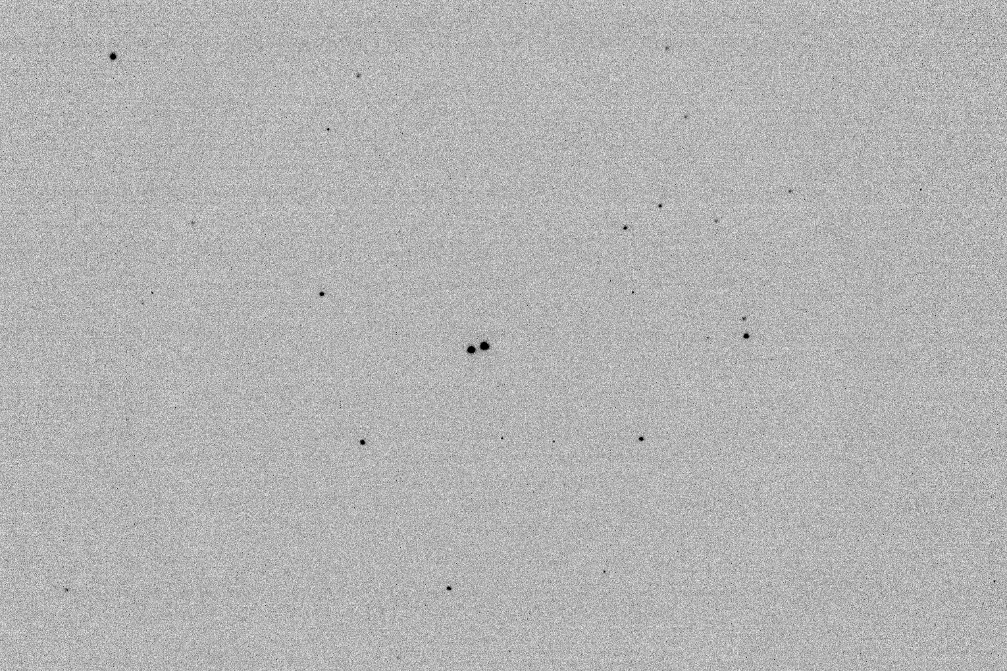

Figure 2: CCD Image of the pair SKF-10

The geometrical idea is pretty simple – draw a line from the primary star to the secondary star, measure the length of the line (ρ), and measure the angle (θ) between that line and the direction pointing north. This begs the questions of how you know the image scale (how many arc-sec per pixel) and the image orientation (which directions are “north” and “east” on your image). CCD double-star observers use image-processing and analysis software to make the necessary calculations and reductions. There are two ways that these software packages handle the necessary computations: “astrometric fitting” and “image scale and orientation”. The next two sections describe the concept and procedure for each of these methods.

2.1 The “Astrometric Fitting” Method

Suppose that you could determine the RA, Dec coordinates of every star in your image. This is the essence of the “astrometric fitting” method of image calibration. The idea is to find a transformation from pixel coordinates to RA, Dec coordinates, such as (in matrix notation):

$$\left[\begin{matrix}\text{RA} \\ \text{Dec}\end{matrix}\right]=\left[T\right]⋅\left[\begin{matrix}x \\ y \\ 1\end{matrix}\right]$$

The transformation matrix [T] describes the scale, position, and orientation of the celestial coordinate frame relative to the pixel coordinate frame. The process of determining the transformation from (X,Y) to (RA, Dec) is often referred to as “matching” the image to an astrometric star catalog. The mathematical details need not concern us here, because you won’t have to do any of it yourself.

2.1.1 “Matching” the image to a star catalog: If you use a CCD, you also have software for viewing, reducing, and analyzing the images – programs such as MaximDL, CCDSoft, AIP4Win, and AstroArt are widely used. Each of these packages can match the image to a star catalog, so that you can retrieve the RA, Dec of each star in the image simply by clicking on it. Deep in the software code, these programs are determining the transformation matrix as part of their matching routine. Astrometric-analysis software packages such as MPO Canopus or Astrometrica also match your image to a star catalog with just a couple of mouse-clicks, enabling you to display the calculated RA, Dec coordinates of any star in the image

An example, using Software Bisque’s CCDSoft, is shown in Figure 3. With CCDSoft and TheSky both open, the CCDSoft command “Research/InsertWCS” conducts a match between the image and the star catalog in TheSky, and reports some information about the results of the matching. Although the exact command and screen shots differ, all of the programs mentioned do this task in very similar ways.

2.1.2 Measuring unknown pairs: Once the image has been “matched”, you can click on any star in the image and the program will display the calculated RA, Dec coordinates of the star. So, click on the two stars of your pair, and jot down their coordinates. Given the RA, Dec of two stars, the separation and position angle are calculated by:

$ρ=\sqrt{(Δα⋅\text{cos}δ_{1})^{2}+(δ_{2}−δ_{1})^{2}}$ (radians) Eq. 1

$Θ={\text{tan}}^{−1}\left[\frac{Δα⋅\text{cos}δ_{1}}{\left(δ_{2}−δ_{1}\right)}\right]$ (radians) Eq. 2

where

$δ_{1}$, $δ_{2}$ are the declination of the primary and secondary stars, respectively
$α_{1}$, $α_{2}$ are the right ascension of the primary and secondary stars, respectively,

$Δα=α_{2}−α_{1}$ is the difference of RA,

and all of these angles are expressed in radians.

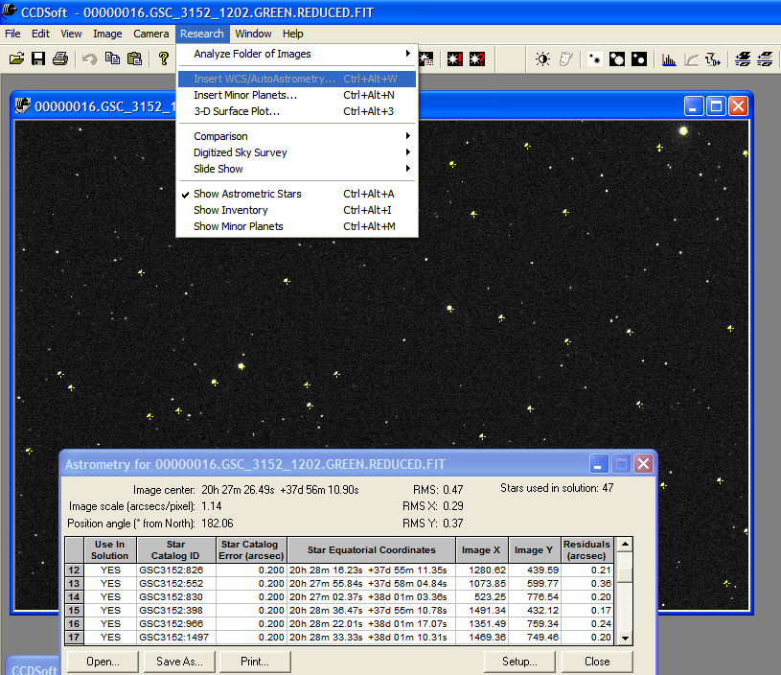

Figure 3: Example of Astrometric Fitting (using CCDSoft and TheSky)

The calculated position angle, $Θ$, must be resolved to the correct quadrant in order to yield the astronomical position angle (θ, measured from celestial north, toward celestial east):

N
E
II
I
III
IV
sign of  $$\left(α_{2}−α_{1}\right)$$ | sign of  $$\left(δ_{2}−δ_{1}\right)$$ | quadrant | position angle $θ$
+ | + | I | $$θ=Θ$$
+ | - | II | $$θ=π+Θ$$
- | - | III | $$θ=π+Θ$$
- | + | IV | $$θ=2π+Θ$$

These calculations can readily be put into a spreadsheet, so that all you need to do is enter the RA, Dec of each of the two stars, and the spreadsheet will calculate ρ and θ. An Excel spreadsheet that does this is available at www.RKBuchheim.org

The MPO Canopus and AIP4Win software will do all of these calculations for you. With their “double star” utilities, you select the primary star and set it as the reference, then select the secondary star, and the separation and position angle are displayed – no calculating required!

2.2 The “Image Scale and Orientation” Method

Any software than can read and display your CCD image will be able to show the pixel coordinates (x,y) of your stars. With that information, you can find ρ and θ in pixel coordinates. In order to translate them from the pixel coordinate frame to the celestial coordinate frame, you need to find the image scale, and the orientation of the celestial coordinate frame in the image.

The “image scale” expresses the magnification of the image, in arc-seconds per pixel. It is denoted by E. It is sometimes referred to as the “plate scale”, in honor of the glass plates that were used before CCD imagers took over the task of recording images at professional observatories. If the distance between two stars is R pixels, then their separation in arc-seconds is just:

$ρ=E⋅R$ arc-sec Eq. 3

The “image orientation” expresses the rotation of the CCD image relative to the celestial coordinate frame. It is denoted by Δ. This is the angle between celestial North and the X- or Y- axis of the image.

The image scale is primarily a function of telescope focal length and the physical size of the CCD pixels, although it can also be affected by focus changes and other secondary effects. Image orientation is primarily determined by the rotation of the CCD camera in the telescope’s focus tube, and of the way the image is read, stored, and analyzed, although again there are secondary effects that can affect the orientation angle. Therefore, these two parameters (E and Δ) must be determined for each observing session – which I’ll refer to as “calibrating” the images for that observing session. If the camera is not moved, these parameters will change little (if at all) from night to night; but it is a necessary discipline to check the calibration for each imaging session to ensure the best accuracy of your measurements. Fortunately, the calibration requires no more than a couple of images, so it doesn’t impose a troubling loss of observing time. The reduction of the calibration images also isn’t too time-consuming.

2.2.1 Determining the image scale (E) and image orientation (Δ): The image scale and orientation are determined by analyzing images of one or more “known pairs”, whose separation and position angle are accurately known. Then, using the values of E and Δ determined from these “known pairs”, it is a simple matter to translate images of other pairs from pixel coordinates (x,y) into separation and position angle (ρ,θ).

The concept of this method is illustrated in Figure 4. In order to use this method you need to know the approximate orientation of the CCD image (i.e. roughly which way is “N” and which way is “E” on the image). Position angle is always measured from North toward East, so you need to know whether that means “clockwise” or “counterclockwise” on your image. There are two ways to determine this: “eyeball matching” your image to a chart from a planetarium program, or using a star trail image. For most imaging setups it is common practice to compare your image to the chart on your planetarium program, to (for example) properly frame the image and adjust any pointing errors. Most planetarium programs will display a compass rose showing the cardinal directions (N, E, S, W). From that, you can easily see (and record in your notebook) the image orientation.

If for some reason “eyeball matching” to your star chart isn’t practical (perhaps a very narrow FOV, or a sparse field where there aren’t enough stars to compare the image to chart), then you can make a star trail image. Open the shutter, wait a couple of seconds and then stop the clock drive. The “blotch” on the star trail (i.e. the deeper exposure before the clock-drive was stopped) shows the Eastward (starting) location of the star trail. Midway through the exposure, nudge the telescope a bit toward the South. The resulting “bump” in the star-trail will point Northward on your CCD image. In the example shown in Figure 4, θ increases counterclockwise, but depending on your setup – the type of telescope, the presence of a star-diagonal, etc. – the opposite may be true for your images.

Now, make an image of a “known pair” – a pair of stars whose separation and position angle are accurately known. From this image, we will determine the plate scale (E) and image orientation angle (Δ). Determine the position of each star, in pixel coordinates:

Primary star = (x₁, y₁) Secondary star= (x₂, y₂)

If the known separation of the calibration pair is ρ_{cal} (in arc-sec), the plate scale is calculated by:

$E=\frac{ρ_{\text{cal}}}{\sqrt{[(x_{2}−x_{1})^{2}+(y_{2}−y_{1})^{2}]}}$ arc-sec per pixel Eq. 4

The angle to the secondary star in the pixel coordinate frame will be called β_{cal}, defined by

$\text{tan}(β_{\text{cal}})=\frac{\left(y_{2}−y_{1}\right)}{\left(x_{2}−x_{1}\right)}$ so that $β_{\text{cal}}={\text{tan}}^{−1}\left[\frac{\left(y_{2}−y_{1}\right)}{\left(x_{2}−x_{1}\right)}\right]$

The image orientation angle (Δ) is the rotation of the image relative to the celestial coordinate system – you can think of it as the angle between the X-Y axes of the CCD pixel array and the RA-Dec axes of the sky. We know that the position angle of the calibration pair is θ_{cal} (relative to the celestial frame). By reference to the example in Figure 4, you can see that

$θ_{\text{cal}}=β_{\text{cal}}−Δ+Nπ$ so that $Δ=β_{\text{cal}}−θ_{\text{cal}}+Nπ$ Eq. 5

The term Nπ indicates that – because of the quadrant ambiguity in the arc-tan function – you will need to examine the graph of your image, and adjust the calculated value of tan⁻¹(Δy/ Δx) to put it into the correct quadrant, with N= 0, 1, or 2 depending on the quadrant.

By the way, you can use astrometric fitting as a way to determine the image scale and orientation, or to check your calculations. Look back at Figure 3: The information that was displayed about the astrometric fit of the image included the image scale (E=1.14 arc-sec/pixel) and image orientation angle (Δ= 182.06 degrees). Most (but not all) astrometric fitting programs report this information, which you can either use “as-is”, or use as a check on your calculations from the “known pairs”.

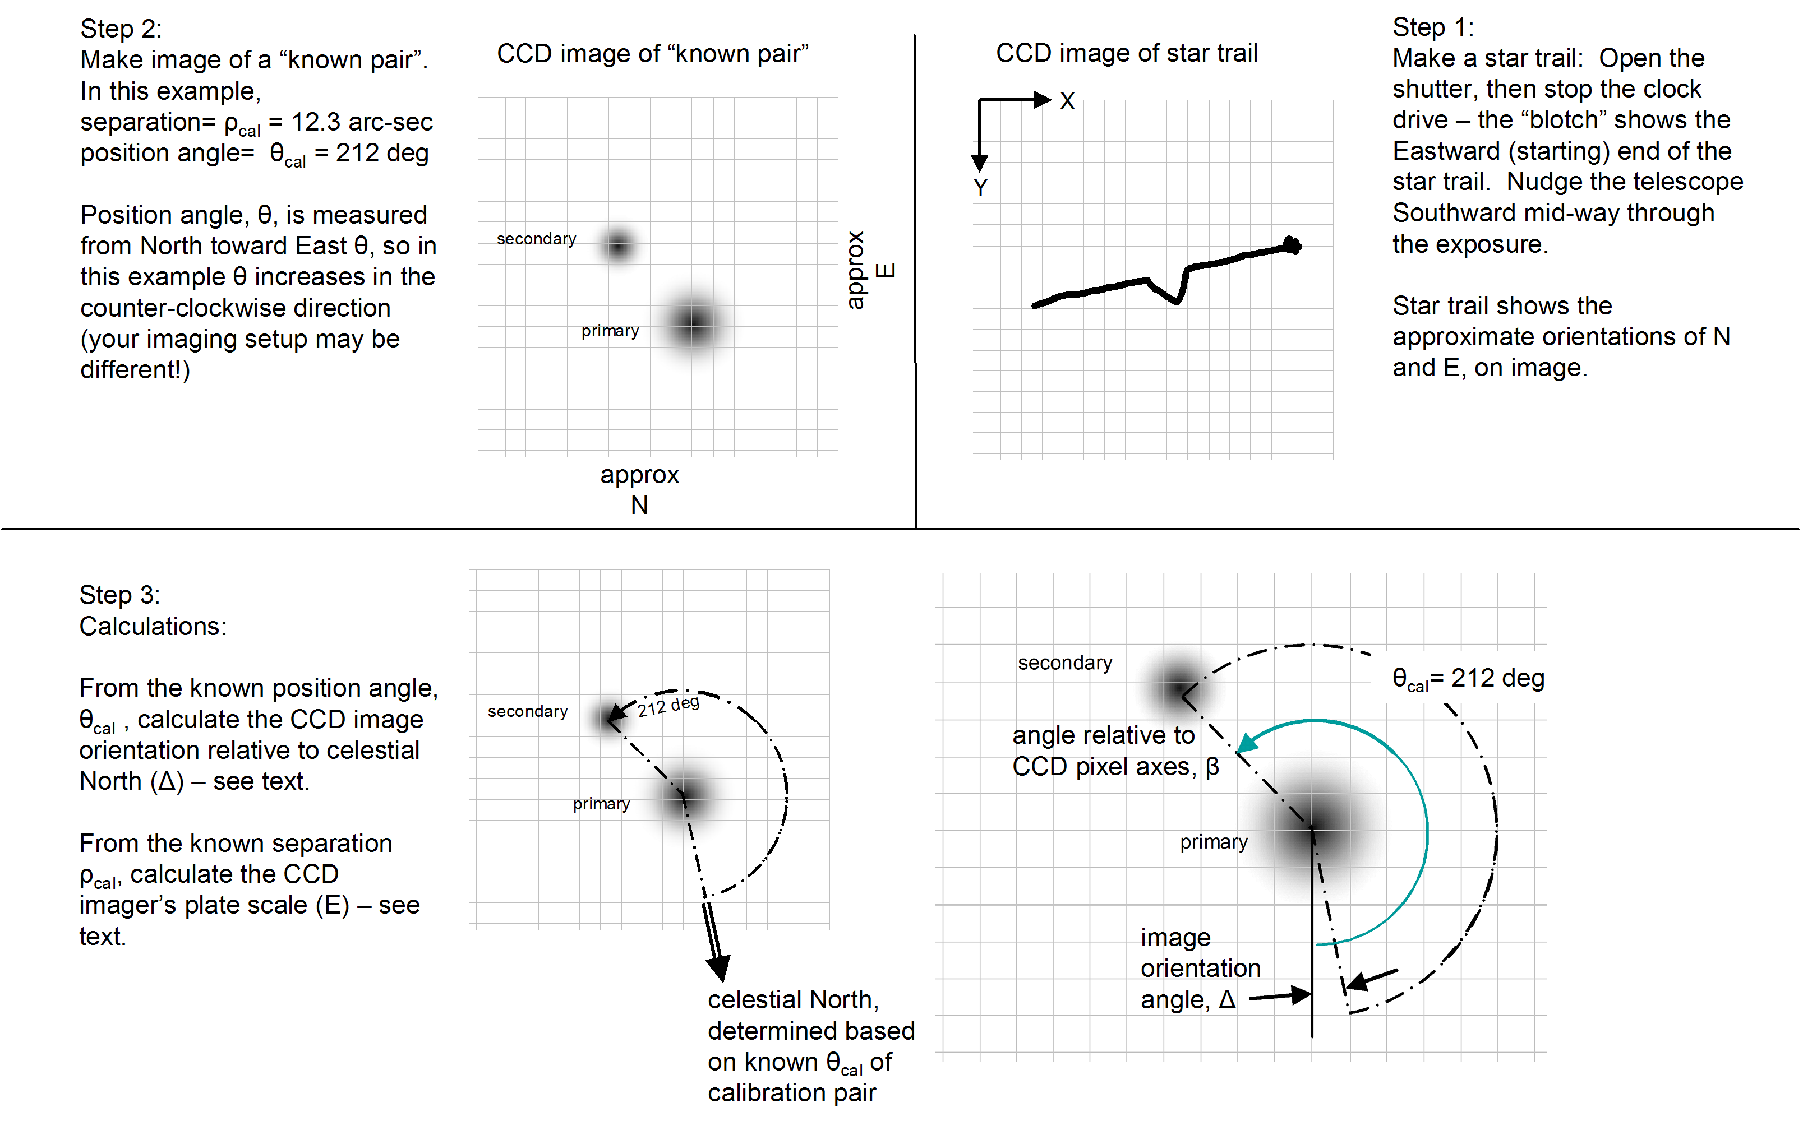

Figure 4: Using a “Calibration pair” to determine image orientation

2.2.2 Measuring unknown pairs: Now that you know E and Δ, you can determine the separation and position angle of any pair on any image. Just determine the pixel coordinates of the two stars,

primary star position = (x₁, y₁)
secondary star position = (x₂, y₂)

and apply the following equations:

$ρ=E⋅\sqrt{(x_{2}−x_{1})^{2}+(y_{2}−y_{1})^{2}}$ arc-sec Eq. 6

$θ={\text{tan}}^{−1}\left[\frac{(y_{2}−y_{1})}{(x_{2}−x_{1})}\right]−Δ+Nπ$ radians Eq. 7

Always make a little graph (like Figure 4-d) to confirm that your calculation of the inverse tangent is in the correct quadrant. Depending on the orientation of celestial axes relative to the CCD X and Y axes, you may need to adjust the results by ±180 degrees (±π radians) to put it in the correct quadrant.

This method of calibrating your images is nicely automated in the software package REDUC, which does all of the math and turns this method into a very quick and easy procedure.

III. Special-purpose software

Your normal CCD image-processing software can do a fine job of analyzing most of your double-star images so that you can use Eq. 1 and Eq. 2, or Eq. 6 and Eq. 7, to determine the separation (ρ) and position angle (θ). CCDSoft+ TheSky, MaximDL, AIP4Win, and AstroArt are all quite capable programs in this regard. AIP4Win even includes a distance-measurement tool that determines the separation and position angle of any two stars in the “matched” image.
If you catch the double-star bug, you may find that the additional features of special-purpose software applications are useful to you. Three such programs that I am most familiar with are Astrometrica, MPO Canopus, and REDUC.

Astrometrica, by Herb Raab, is a general-purpose astrometry program. Some of the unique features of Astrometrica that are useful for double-star measurements include:
- With an image open, a one-click command will match the image to a reference star catalog. With the matched image, you can click on any object, and a window opens showing you the (calculated) RA, Dec, magnitude, and some information about the quality of the fit. The RA, Dec from each star in a pair can then be entered (by you) into a spreadsheet, to use equations Eq.1 and Eq.2 to calculate the ρ,θ.
  - Astrometrica will open and astrometrically analyze a batch of images with a single command.
  - It supports a wide array of modern astrometric catalogs. The catalogs can be stored on your local hard disk, or accessed over the internet. Large, modern astrometric catalogs such as UCAC3 and USNO-B1.0 can be loaded onto your local hard drive (e.g. 7.9 GB for the 100,766,420 objects in the UCAC3, with positions accurate to about 0.02 arc-sec and including proper motion). The internet-access feature is quite seamless, and enables you to access a variety of astrometric catalogs, including the 100 GB “NOMAD” catalog.
  - It is the only program I am aware of that allows you to select higher-order plate constants. Most programs use first-order plate constants, which in effect mean that they assume that the image scale and orientation are constant across the image. This is usually a quite good assumption, but if you have a wide-FOV system, or field curvature or any of a variety of possible aberrations, the use of higher-order plate constants may be helpful.
  - Astrometrica uses a form of PSF-fitting in order to determine the location of stars. For bright, isolated stars, there is no noticeable difference between this PSF approach and the intensity-centroid approach used by most other programs. However, for closely-spaced pairs, where the star’s images begin to touch, Astrometrica’s algorithm seems to do a better job of separately locating the two stars.

Astrometrica is distributed by internet download. It can be purchased at www.astrometrica.at. As of this writing, the license costs €25. Astrometrica is “shareware”, so you can download and use it for 100 days to confirm that it meets your needs, before paying the license fee.

MPO Canopus, by Brian Warner, is a full-feature astrometric and photometric program. . Some of the unique features of MPO Canopus that are useful for double-star measurements include:
  - MPO Canopus includes a clever double-star utility. One click on each star in the matched image, and the double-star utility calculates, displays, and reports the separation and position angle of the pair (i.e. no need to work through Eq. 1 and Eq.2).
  - MPO Canopus’ double-star utility will correct the position angle for precession, to the epoch of observation. (See the discussion below on precession). The preferred reporting of position angle is based on the pole and equator of the epoch of the date of observation, which MPO Canopus will do automatically. Other “astrometric fitting” algorithms inherently report the position angle based on the pole and equator of the epoch of their underlying catalogs. This is usually a small effect, unless the pair being measured is very close to the celestial pole, or the astrometric catalog is outdated.
  - It can use of any of several astrometric catalogs, including USNO-A1, USNO-A2, UCAC-3, and the proprietary MPOSC3 astrometric/photometric catalog.
  - It includes a convenient utility for automatically measuring a batch of images of a pair, analyzing the measurements, and creating a report.
  - MPO Canopus has the ability to sum images in 32-bit format, which expands the numerical dynamic range of the calculations. (See the discussion of dynamic below on dynamic range).

MPO Canopus is distributed on a DVD which includes the program and the MPO photometric and astrometric Star Catalog with ~300M stars. It can be purchased at www.minorplanetobserver.com. As of this writing, the licensed DVD costs $65. A multi-seat educational license is available for the same price.

REDUC was developed specifically for double-star measurements by Florent Losse. It implements and streamlines the use of the “image scale and orientation” method. Some of the unique features of REDUC are:
  - REDUC has routines that will calculate your plate scale (arc-sec/pixel) and field rotation based on one or more known pairs.
  - REDUC can use either a known pair alone, or a known pair plus a star trail image to define the image orientation.
  - It offers “two-click” measurement of the position of each star, with automatic calculation of the separation and position angle of the pair. Manual-entry or “known pair” determination of plate scale (arc-sec/pixel) can be used.
  - It does a fine job of accepting a batch of image files of a double star, automatically reducing all of them, and creating a report with each image’s results, plus the average and standard deviation of the batch. REDUC can read both integer FITS and IEEE 32- and 64-bit floating point images; and all computations are done in high precision regardless of the input format, for expanded numerical dynamic range (see the discussion below on dynamic range).
  - Its image-evaluation utility sorts a batch of images in order of quality
  - Automatic calculation of ρ,θ as each image/pair is measured
  - Automatic report-preparation
  - REDUC includes a “Surface” routine that implements a version of PSF image modeling to accurately measure very close pairs, whose PSFs overlap significantly. This is the only program that I’m aware of that can reliably and accurately measure pairs that are so closely spaced that their images overlap noticeably.
  - Its magnifying and re-sampling algorithm can help separate closely-spaced pairs for measurement.
  - REDUC includes a set of tools dedicated to speckle interferometry.
  - REDUC is freeware! This very sophisticated package is available free, upon request from the author.

Go to the author’s website at www.astrosurf.com/hfosaf/, and follow the instructions to request the software download.

IV. Mathematical Considerations

The idea of determining separation and position angle is an easy concept – you probably worked this problem in your high school Trigonometry class. That really is all that is required to make a double-star measurement using your CCD image, and as we’ve seen, there are several choices of software packages that will do most of the arithmetic for you. So, it isn’t absolutely necessary that you know what is going on inside those software packages. However, in order to understand the rationale behind some of the advice that is given in the sections about the imaging equipment, procedures, and pitfalls, it helps to peek through the curtain of the mathematical methods.

4.1 Position of Stellar Image – Intensity Centroid and PSF match

A star’s image is not a mathematical point. How do we define the “location” of the star? How do we measure the location? And, can we determine the star’s location more accurately than ±1 pixel? It is worthwhile to look closely at the CCD image of a single star while considering these questions.

4.1.1 The Point Spread Function: When your telescope focuses on a single star it forms an intensity distribution on the focal plane (the CCD chip), called the Point Spread Function (PSF). Ideally this is a smoothly peaked brightness blur, which represents the convolution of the telescope’s diffraction and aberration characteristics, the atmospheric effects, and any “accidental” defects such as tracking error, as shown in Figure 5. The CCD chip then does three things to this smooth PSF: it spatially integrates the brightness over each individual pixel, it samples the pixels, and it adds several types of random noise. The net result of this is a discretely-sampled, noisy version of the intensity distribution. The exact nature of this sampled PSF depends on the size of the pixels, and where the star is registered on the pixel array.
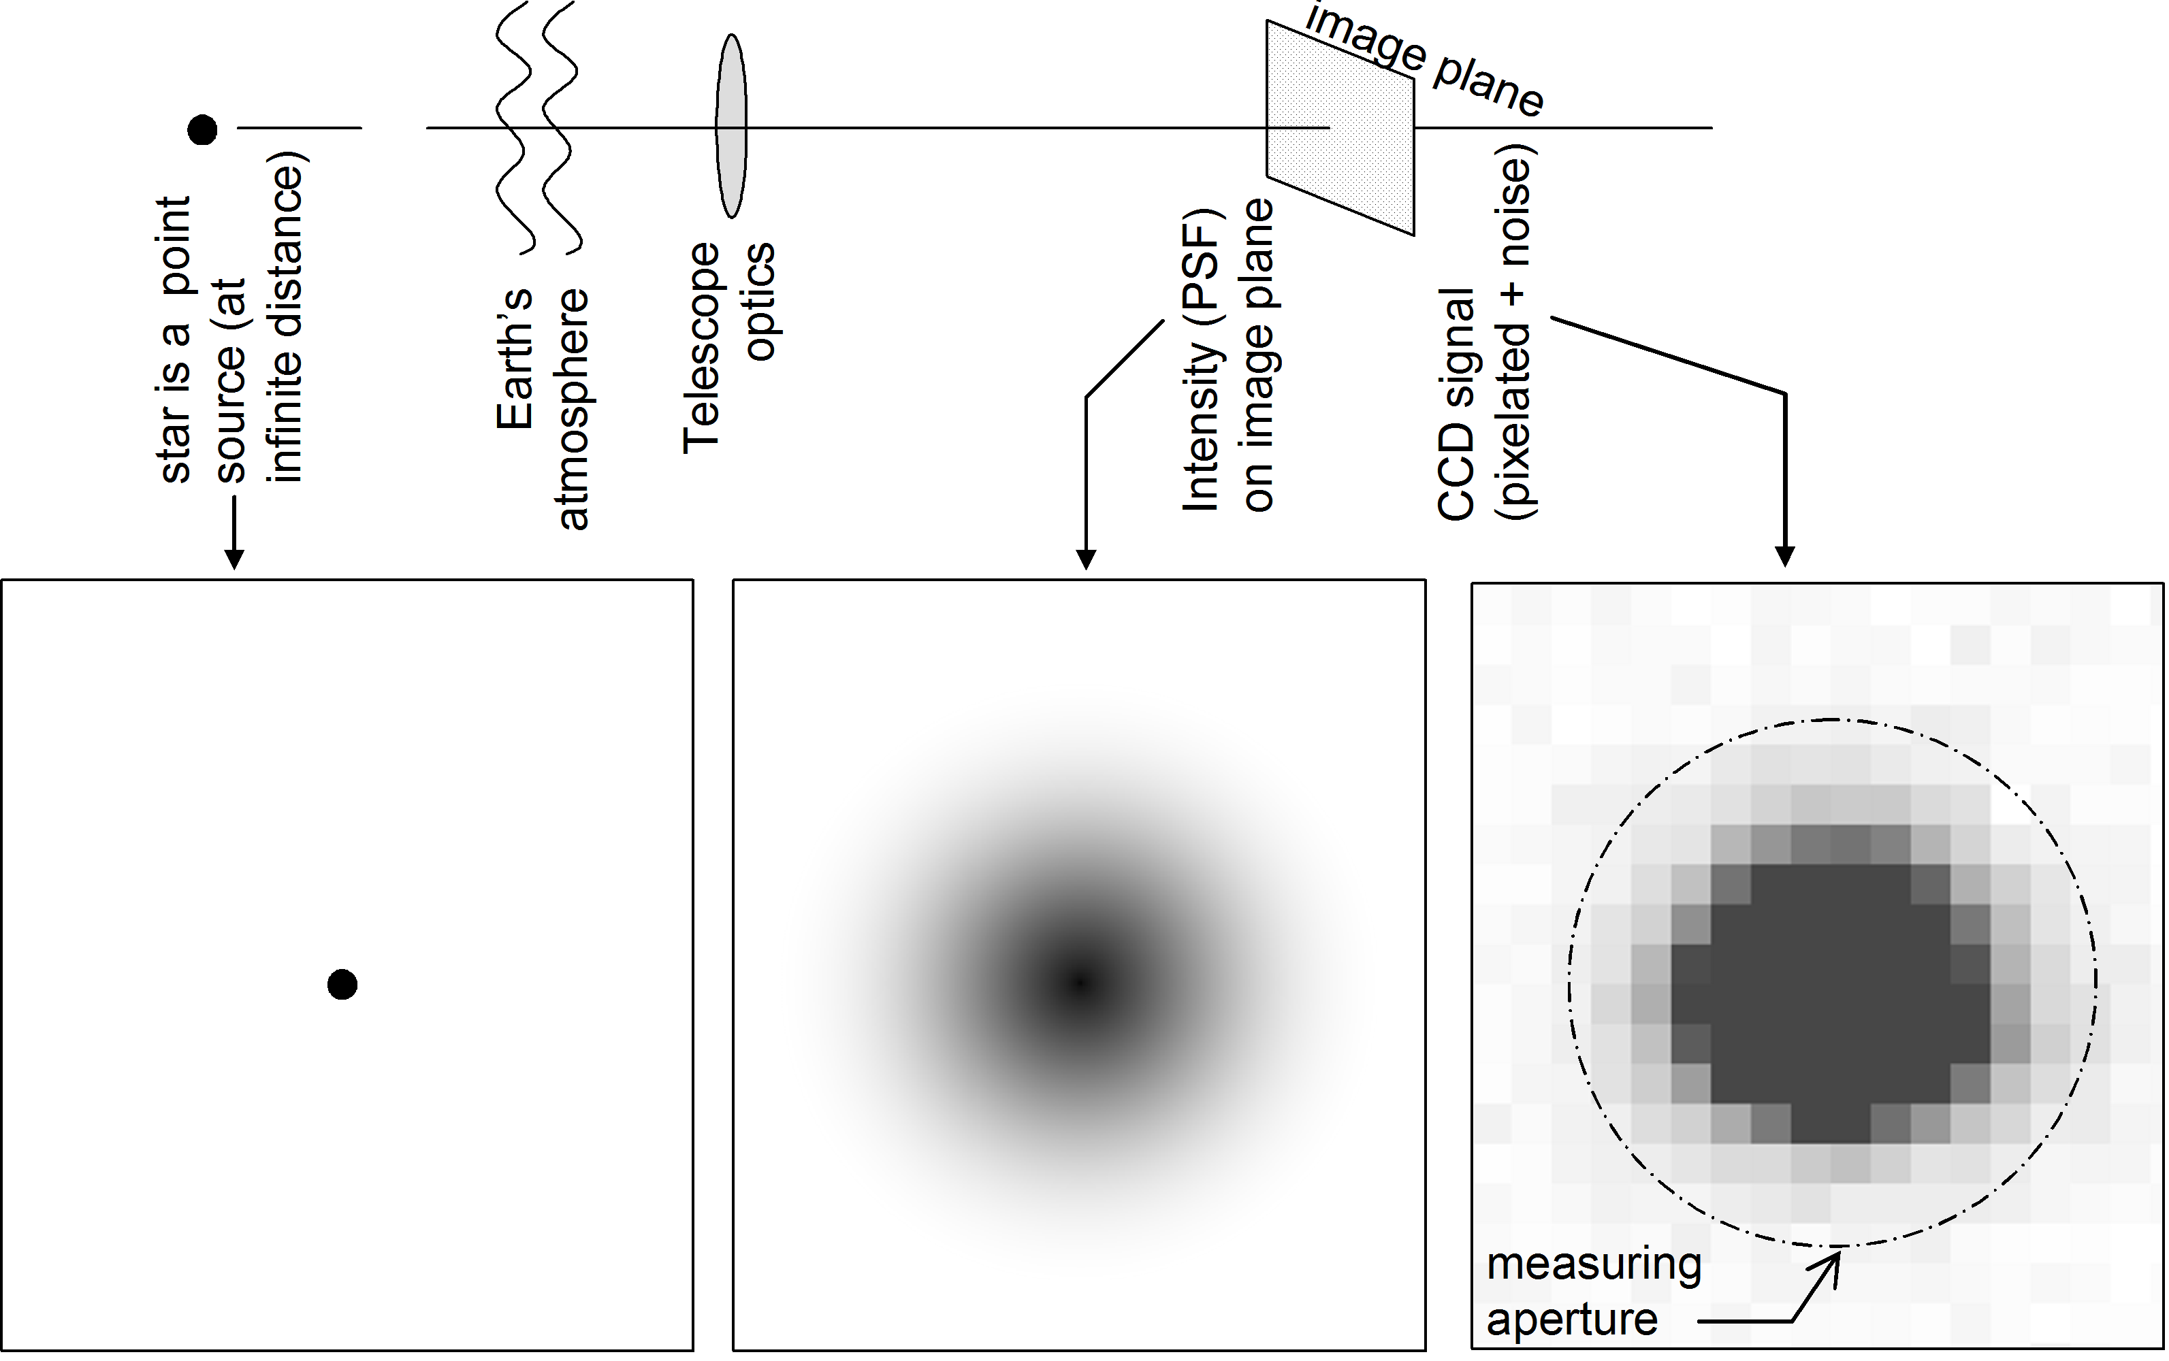

Figure 5: The CCD’s image of a star – the Point Spread Function (PSF) – is a blurred, discretely sampled intensity distribution, with random noise added.

The width of the PSF is frequently described by its full-width-at-half-maximum (FWHM). The FWHM may be expressed in either pixels or arc-seconds, depending on the context.

An important feature of the sampled PSF is that even in the absence of noise, the center of the brightest pixel may not be the best estimate of the location of the center of the star’s underlying Intensity PSF. An illustrative example of this is shown in Figure 6, for a case of 5 μm pixels, and the star’s “true” center falling 2 μm to the right of the “center” pixel. Simply assuming that the brightest pixel is the position of the star would be in error by nearly half a pixel width. We can do much better than that!
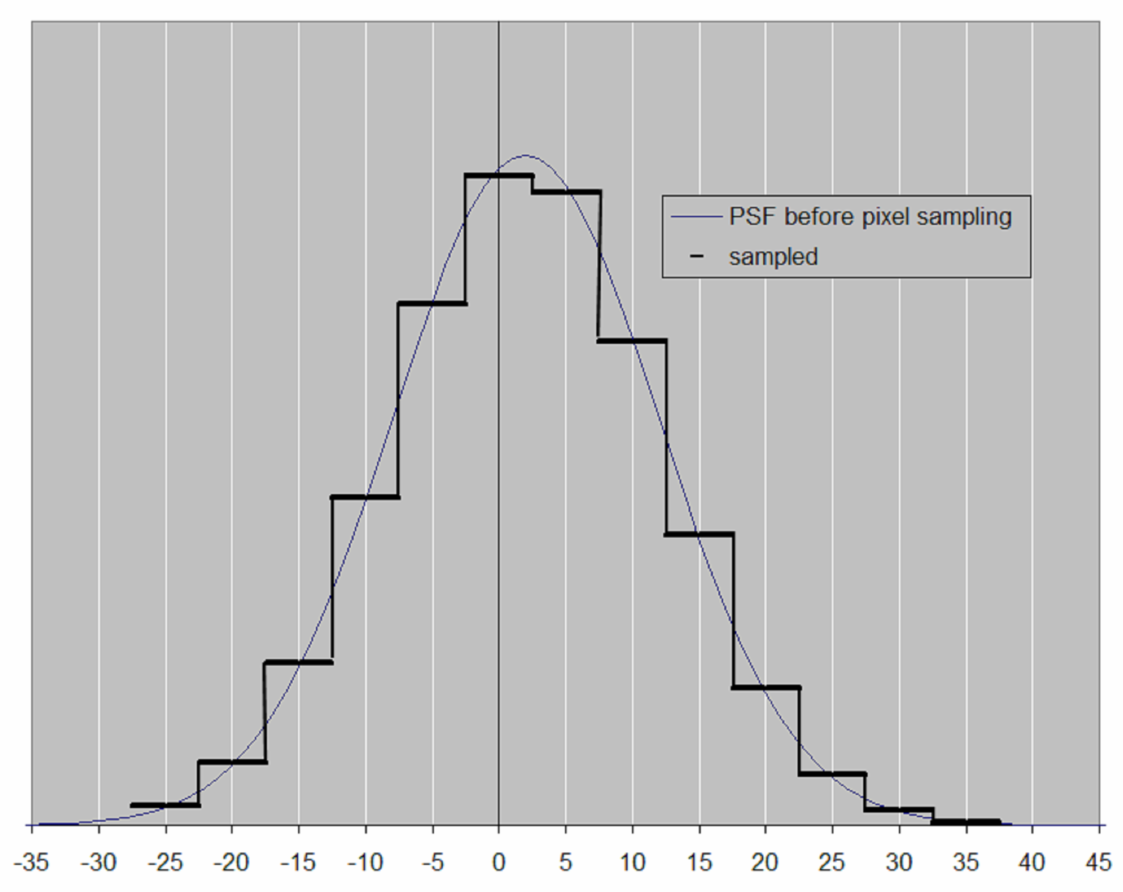

Figure 6: The center of the “brightest pixel” is not the best estimate of the star’s position

4.1.2 Intensity Centroid and PSF fitting: The best estimate of the location of the star’s image is usually taken to be the intensity centroid of the sampled point spread function. If I(x,y) is the star-image intensity distribution, and (x,y) are pixel coordinates, then the coordinates of the intensity centroid are:

$X_{C}=\frac{\sum{x⋅I(x,y)}}{\sum{I(x,y)}}$ and $Y_{C}=\frac{\sum{y⋅I(x,y)}}{\sum{I(x,y)}}$ Eq. 8

The summations extend over the “measuring aperture” – the small portion of the CCD image that encompasses the star. The measuring aperture may be square or circular depending on the software that you use. Either is quite acceptable. The measuring aperture should be large enough to capture all of the star’s light, but not so large that it captures a great deal of background sky, nor any other nearby stars. A typical starting choice is a measuring aperture that is about 2 to 3 times the FWHM of your star images.

There are two important features of these equations for the centroid.

If the pixels are too large, then the star’s location can be lost inside the large pixel. Suppose that the pixels are so large that only a single pixel has light on it. This is the situation illustrated in Figure 7b. The equations then tell us the location of that one-and-only illuminated pixel: the best estimate of the location of the star is the centroid of that one-and-only pixel. In this situation, there is a limit to the accuracy of your position determination – you can’t know the star’s location more accurately than ±0.5 pixel.

As the pixels become smaller (compared with the optical PSF), then the sampled PSF becomes an increasingly more accurate representation of the optical PSF (as in Figure 7a, and Figure 6). The equations can then find the location of the centroid of the star to a small fraction of a pixel. For a typical backyard CCD imaging set-up, with a scale of about 1 arc-sec/pixel, you should be able to achieve position accuracy of a tenth of an arc-second – which is quite remarkable accuracy!

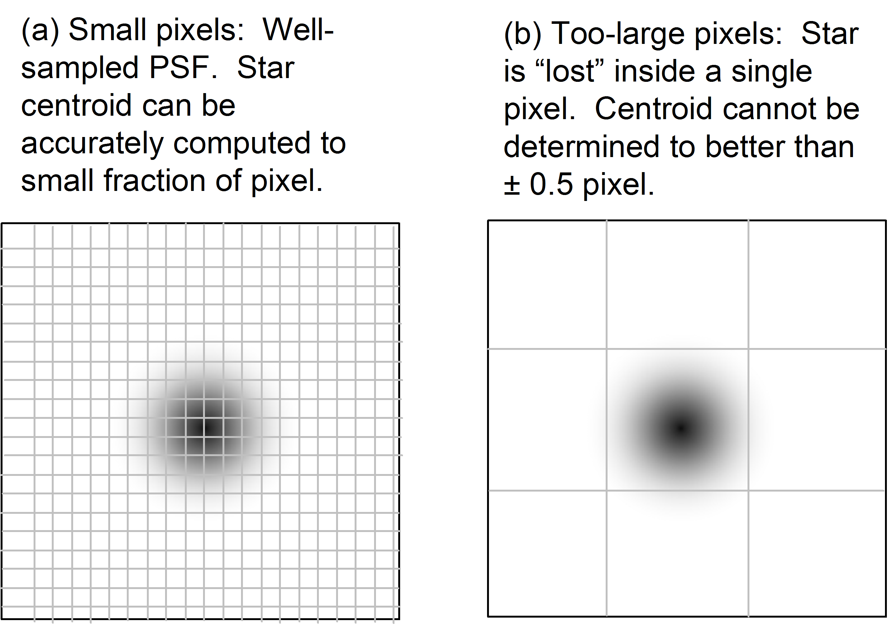

Figure 7: (a) With small-enough pixels (≈0.25 FWHM) the star’s centroid can be determined to a small fraction of a pixel. (b) With too-large pixels, the star can be “lost” inside a single pixel.

An alternative definition of the “location” of the stellar image, called “PSF fitting”, is sometimes used. In particular, the program Astrometrica uses this approach. The idea is to construct a mathematical/theoretical PSF, and then find the best fit (position, intensity) between the mathematical PSF and the actual image.

Call the actual image intensity distribution

$$I_{\text{IMAGE}}(x,y)$$

and let the mathematical model of the PSF of a single star be

$$\text{PSF}(x,y)=A_{0}⋅f[(x−x_{0}),\left(y−y_{0}\right),w]$$

where the center position of the model star is (x₀, y₀), its intensity is A₀, and the “spread” of the PSF is described by the parameter w.
The function $f$ can be any well-behaved function that reasonably matches the shape of the PSF – different authors have used Gaussian, Moffat, and polynomial functions. (Astrometrica uses a Gaussian model).

The “PSF fitting” algorithm finds the mathematical model that is the best fit to the real image by searching for the values of x₀, y₀, A₀ and w that will minimize the sum-square error:

$χ^{2}=\sum{{\left[A_{0}⋅f(x,y;x_{0},y_{0})−I_{\text{IMAGE}}(x,y)\right]}^{2}}$

where the summation extends over all pixels in the measuring aperture of the image.

As long as the image has a high signal-to-noise ratio, is well-formed, well-sampled, and not affected by neighboring stars, the “centroid” and “PSF fit” will give the same result for the position of the star.

4.2 Position of Double-Star Images

The image of a close pair of stars is just the sum of their two PSF’s. Figure 8a shows the intensity profile of a widely-spaced pair of unequal magnitudes, displaying two distinct peaks. In this situation, it is practical to determine the position of each star by calculating its centroid, because there is a reasonably clear boundary between the stars.

As the separation becomes smaller (Figure 8b), the stars become so close together that is isn’t possible to measure their individual centroids. With no clear boundary between the stars, their individual PSFs have blended into a single blur, and wherever you place the measuring aperture for star#2, it will inevitably include some of the light coming from star#1, which of course invalidates the centroid calculation. The greater the magnitude difference, the wider the pair must be in order to cleanly distinguish the two stars. Note that the situation can easily result in there not being two distinct peaks in the combined intensity distribution. Instead of a secondary “peak”, the fainter star may be represented by only a bulge in the side of the PSF.

How close is “too close to measure”? The point at which such an overlapping intensity profile becomes “too close to measure” depends on a variety of factors. The larger the delta-magnitude, the more widely separated the stars must be to be measurable. The higher the SNR, the more distinct the fainter star will be. If the width of the star’s PSF becomes smaller (e.g. due to a night of better seeing), then closer pairs can be measured. In general, once the stars become closer than about 2X FWHM, they are difficult to separate. Closer than about 2X FWHM, the centroid algorithm is likely to be problematic because there is no longer a clear separation between the stars’ PSFs.

The “PSF fitting” algorithm can usually derive accurate positions for stars that are somewhat closer together than the “centroid” algorithm can handle. Still, at separation less than 2X FWHM it is likely to also have a hard time separating the stars. One nice feature of Astrometrica in this situation is that the magnified view of the “calculated” and “image” PSFs gives you a good indication of the adequacy of the fit. If the stars are too close to measure it will be obvious on the display.

PSF Image Modeling: When the stars in a pair are so close that their PSFs overlap significantly, any method that relies on separately determining the position of each star will be problematic. As shown in Figure 8, because of the overlap it isn’t meaningful to search for a boundary where one star ends and the other begins; instead, one star’s PSF simply fades into the other. Worse, the centroid of the fainter star may not correspond to a locally brightest pixel. In fact, there might not even be a “locally brightest” pixel marking the secondary star. And any error in finding the centroid of the stars will translate into a quite large error in position angle.
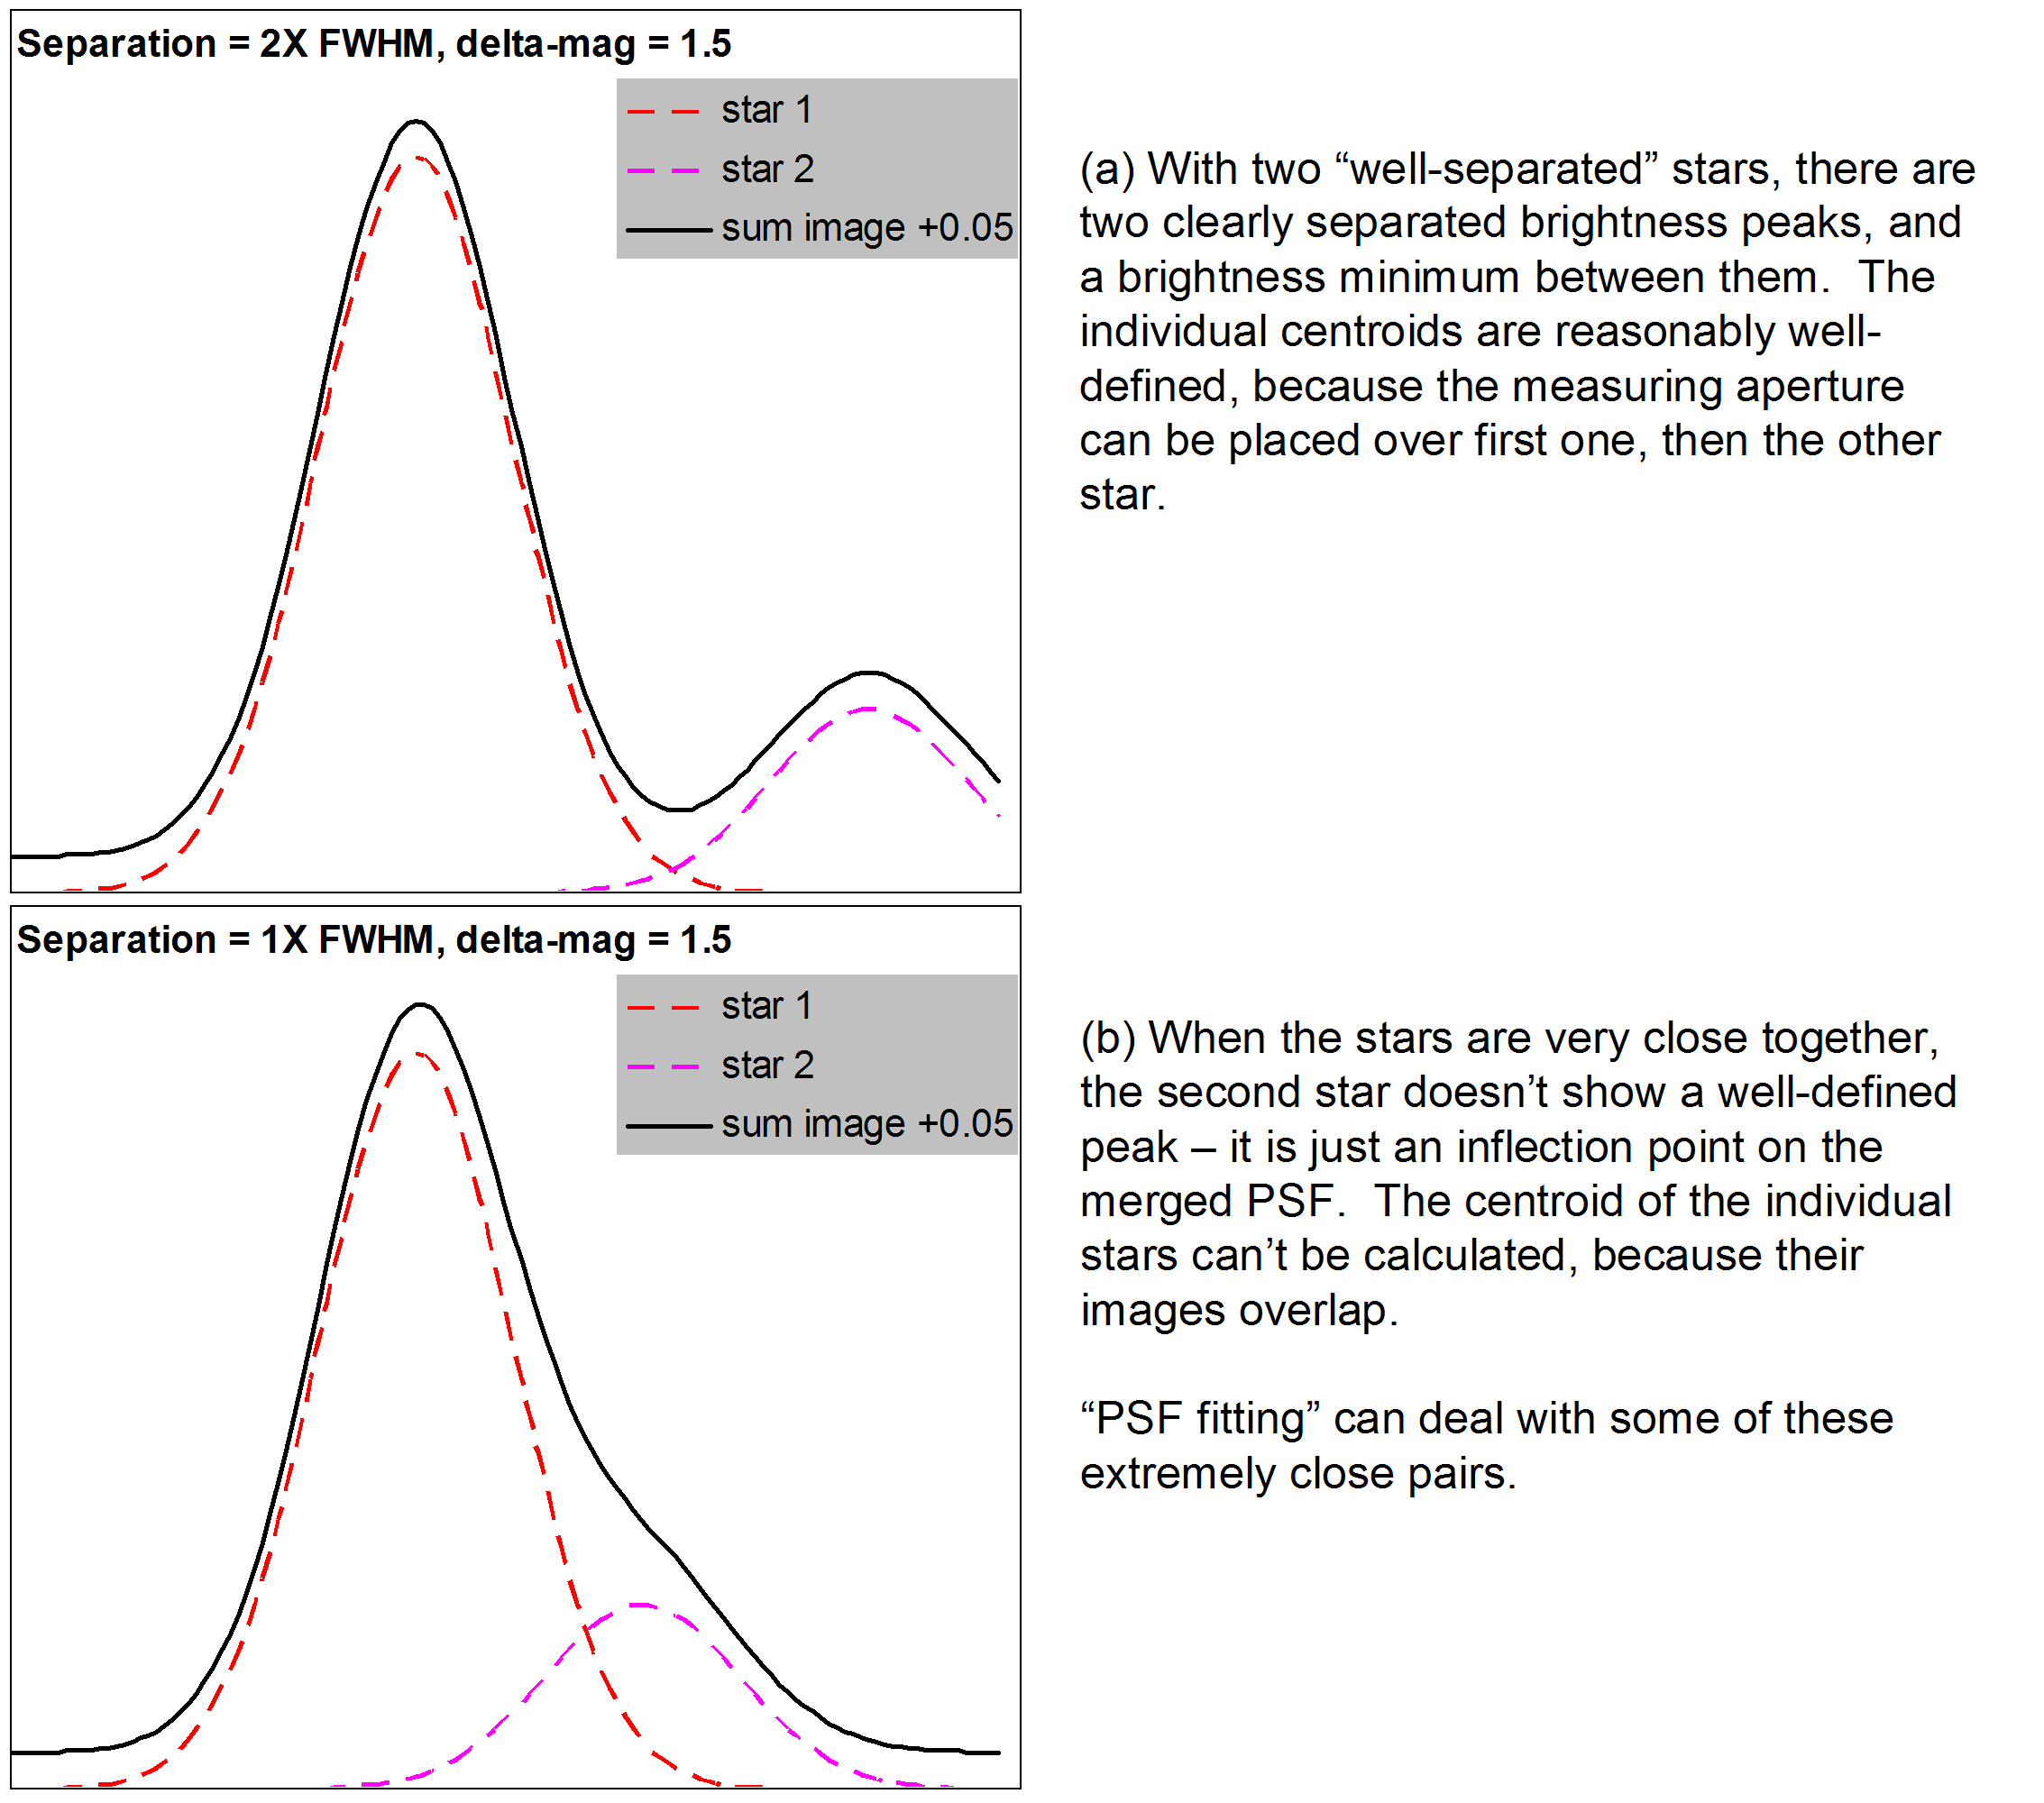

Figure 8: “Too close” pairs do not display distinctly separate images – two stars become one merged image.

One solution to this is to use a mathematical approach that is an extension of PSF fitting. Instead of finding/measuring the position of each star individually, you make a mathematical model of two overlapping PSFs, and find the separation/position angle that minimizes the difference between your math model and the actual image intensity distribution. Much closer pairs – down to about 1X FWHM – can be measured with such a “PSF image modeling” algorithm (assuming well-sampled images, good SNR, and not-too-large magnitude difference).

As before, call the actual image intensity distribution

$I_{\text{IMAGE}}(x,y)$ .

The mathematical model of two stars, centered at (x₁, y₁) and (x₂, y₂) respectively, is the sum of their two PSFs, scaled by their relative brightness. Call this the “model” intensity distribution:

$$I_{\text{MODEL}}=A_{1}⋅f[(x−x_{1}),\left(y−y_{1}\right),w]+A_{2}⋅f[(x−x_{2}),\left(y−y_{2}\right),w]$$

where A₁ and A₂ are the relative brightness of the stars, and w describes the width of the PSF function (e.g. the σ if a Gaussian PSF model is used). The squared-difference between the image and the model is:

$$χ^{2}=\sum_{x,y}{{\left[I_{\text{IMAGE}}−I_{\text{MODEL}}\right]}^{2}}$$

The challenge is to search for the values of x₁, y₁, x₂, y₂, w, A₁ and A₂ that minimizes χ², and to compare I_{IMAGE} to I_{MODEL} to confirm that the model is, indeed, a good match to the actual image.

This approach is quite a bit more work than using “astrometric fitting” or “image scale and orientation”, with their user-friendly commercial programs, but it does permit the accurate measurement of pairs that would otherwise be too close to deal with. An example of a very close pair (separation slightly less than 1X FWHM) is shown in Figure 9.

I am not aware of any commercial software that implements this method, although the “Surface” routing in REDUC is a very similar formulation. The necessary calculations can be programmed into a spreadsheet. Most modern spreadsheet programs (e.g. Microsoft Excel) include iterative solvers that will search for the parameter values that give the best fit between model and image. It is important to beware that the spreadsheet solvers do not provide estimates of the uncertainty or confidence interval of the solution, so if you use this method it is mandatory that you analyze several images of the pair, to assess the uncertainty range of the results.
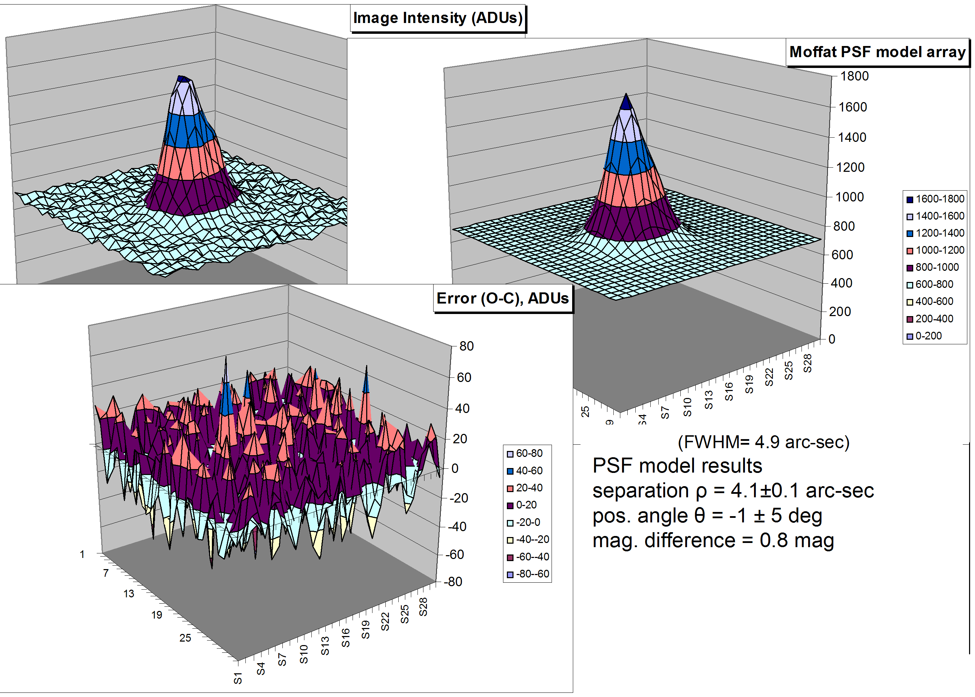

Figure 9: Example of the capability of PSF-modeling to measure a very close pair on a CCD image

V. Considerations Related to Atmospheric Effects

We live at the bottom of an ocean of air, and the atmosphere causes a variety of distortions and degradations to starlight before that light enters our telescopes. Whereas photometrists prize the clearest nights, and deep-sky astro-imagers are happiest under the darkest sky, the condition of most value to double-star measurements is stability: no atmospheric turbulence to blur the star images. Measurement of double stars is not noticeably affected by haze, light pollution, or moonlight, so this is one project that can be pursed on those full-moon nights where deep sky observing or photometry are not practical. And if conditions are poor one night, you can simply try again – unlike comets and asteroids the double stars will be available in the same place for a repeat attempt on a better night!

The air scatters and absorbs starlight, so that in general any star will appear fainter and redder when it is near the horizon than it does when it is at the zenith. This effect is very important for photometry and spectroscopy, and as a result astronomers have developed a variety of ways to determine (and compensate for) this effect. It does not have a direct adverse impact on double star ρ,θ measurement, but you may have to consider it if you are measuring the magnitude/color difference between the two stars.

The air also bends starlight, and this bending can (roughly) be thought of as three effects: refraction, turbulence, and dispersion.

5.1 Refraction: Refraction refers to the fact that a light ray is “bent” by the density gradient of the atmosphere (dense near the surface, tenuous at high altitudes). The closer a star is to the horizon, the greater the displacement between its “observed” position and its “true” position. This effect is illustrated in Figure 10. Refraction always makes the star appear to be higher in the sky than it would be in the absence of Earth’s atmosphere; and the change of refraction angle as the star moves away from the zenith is quite spectacular. It is this effect that causes the “oval-shaped” Sun when it sets over a low horizon.

Happily, the effect of refraction on measurement of double stars is quite modest. Since both stars of a double-star pair are very close to each other, they are refracted almost identically, so that their measured separation is nearly unaffected. The magnitude of the difference in refraction between the two stars in a pair (assumed to be aligned vertically, which is a worst-case assumption) is shown in Figure 10c. When the double star is fairly high in the sky, (say zenith distance less than 60 degrees, i.e. 30 degrees or more above the horizon) you can usually neglect this effect, since it is much smaller than the probable accuracy of your measurements

5.2 Turbulence (“seeing”): Atmospheric turbulence makes stars “twinkle”, and moves the star images around randomly. For most situations, the CCD exposure is long enough that these random motions are time-averaged into a smooth blur (the Point-Spread Function), and the center of the blur is a good estimate of the position of the star on the image plane. Very short exposures (such as those used in “lucky imaging”, as discussed in Chapter __) can “freeze” the turbulent motion, so that the star’s image becomes a nearly-perfect diffraction-limited spot; but still, the turbulence will cause that spot to move about, so that each short-exposure image places the star-spot in a slightly different location on the image plane. The image may be nearly diffraction-limited, but it still bounces about a bit from image to image.

Will two adjacent stars “bounce about” in exactly the same way, or will the atmospheric turbulence cause them bounce toward and away from each other, thereby changing the separation and/or position angle? Theoretical studies show that they do, indeed, bounce toward and away from each other. The magnitude of the RMS separation change depends on the details of the atmospheric conditions at the time of observation, but most models give pretty similar predictions. The trends are intuitive: the more widely separated the stars are (so that each star “sees” turbulence that is less correlated with what its neighbor “sees”), and the shorter the exposure time (so that there is less time-averaging of the turbulence-induced motions), the greater the relative motion will be. However, for the situations likely to be encountered by backyard scientists, the turbulence-induced relative motion does not have a significant amplitude. The turbulence-induced RMS change in separation is shown as a function of exposure time in Figure 11, for an 8-inch (20-cm) telescope, and pairs separated by 30 arc-sec and 150-arc-sec. When the exposure is longer than a few seconds, the RMS differential position fluctuation caused by atmospheric turbulence is less than 0.1 arc-sec – a tiny fraction of the nominal separation of any measurable pair.
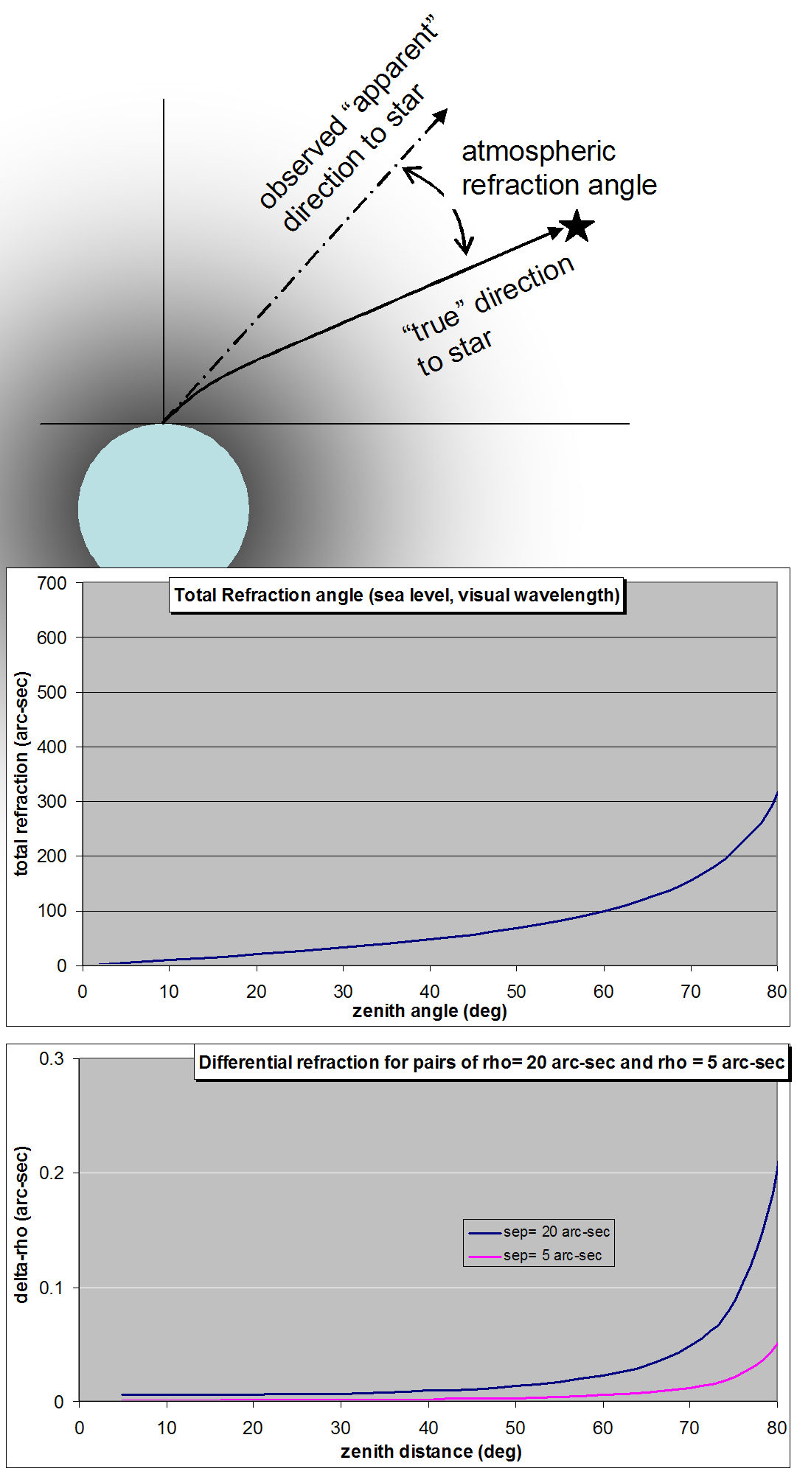

Figure 10: Total refraction and differential Refraction.

So, be aware of this effect, but don’t worry about it unless you are using extremely short exposures. If you must use very short exposures, taking and measuring multiple images and averaging the resulting measurements has the same “time averaging” effect that longer exposures would give, reducing the effective amplitude of this effect.

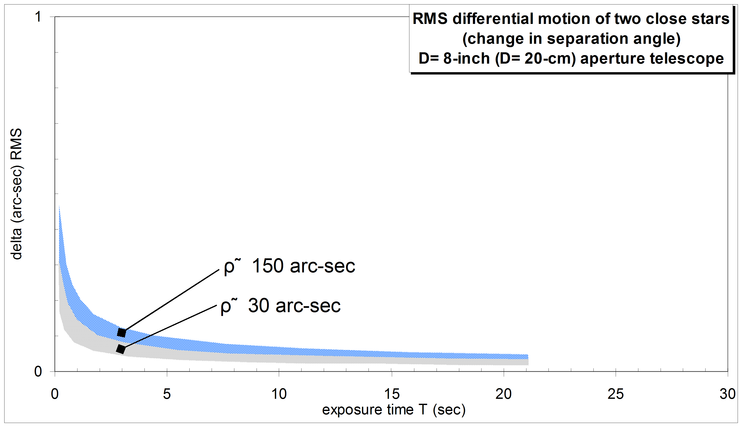

Figure 11: Differential image motion caused by atmospheric turbulence is only noticeably on very short exposure images

5.3 Dispersion: Differential chromatic refraction: The third property of the atmosphere – dispersion – is that it bends blue light more than it does red light (because the refractive index of air is higher in the blue than it is in the red). Each star is thus spread out into a little spectrum, with blue light deflected toward the zenith and red light toward the horizon.

The theoretical amount of differential chromatic refraction as a function of wavelength, for an observatory at sea level, is illustrated in Figure 12. This graph shows the angular dispersion between the indicated wavelengths (colors), and a wavelength of λ=0.5 μm that was arbitrarily chosen as the “reference” wavelength. Note that the dispersion increases dramatically as the viewing direction approaches the horizon. (The dispersion effect becomes smaller for higher elevation observing sites, but the key message – to avoid viewing too close to the horizon – still holds).

These curves show that different colors of light are refracted slightly differently, and that the effect increases dramatically as you approach the horizon (i.e. large zenith angles). Suppose that you were dealing with two stars, one of which was quite blue (radiating only at 0.4 μm), and another star that was quite red (radiating only at 0.6 μm). Further assume that your sensor has uniform sensitivity, regardless of wavelength, and that there is no turbulence in the atmosphere, so that the star images are perfectly small (all of these assumptions are, of course, quite unrealistic, but they help to visualize the situation). In this idealized case, at 50 degrees zenith angle, the blue star is moved by 1 arc-sec (toward the zenith) and the red star by -0.5 arc-sec (away from the zenith), so that their apparent (observed) separation may be between 0.5 arc-sec smaller to 1.5 arc-sec greater than “truth”, depending on which star is higher in the sky. That’s a significant effect, compared to the ≈0.1 arc-sec accuracy that you’re striving for!

In a more realistic situation, the stars radiate in all colors, but the blue star is still a different color than the red star, so the centroids of their spectra are differentially moved, a bit. The CCD sensor is more sensitive to some colors than others (e.g. an unfiltered CCD tends to be more sensitive to green or red than blue light), and this spectral sensitivity curve tends to reduce the impact of differential refraction of starlight. The narrower the CCD’s spectral response, the smaller the effect of differential refraction.

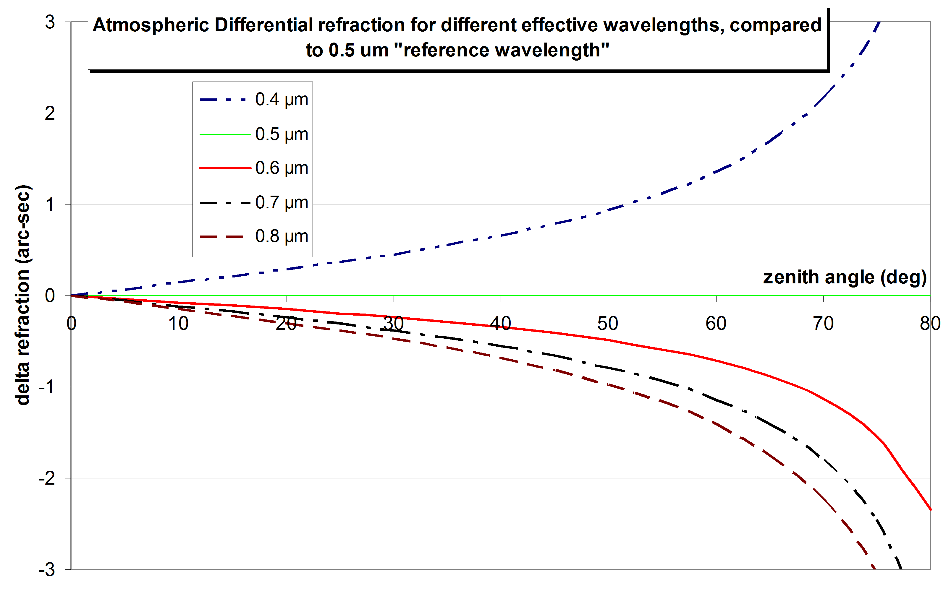

Figure 12: Dispersion (Differential Chromatic Refraction) can be a noticeable effect for sightlines that are close to the horizon.

This atmospheric effect argues strongly for imaging the pairs when they are as high in the sky as practical. In general, “too close” to the horizon means lower than 30-40 degrees above the horizon. This effect also encourages the use of a spectral filter to limit the range of wavelengths that reach the CCD, especially if you are forced to image at large zenith angle, or if you know that the colors of the stars in the pair are quite different. All other things being equal, a Red or Infrared filter is preferred (since dn/dλ is smaller at longer wavelengths).

VI. Considerations Related to Taking and Processing CCD Images

Almost any amateur telescope/CCD combination can be used to make useful double star measurements, so if you already have an imaging system, I encourage you to press it into the service of double-star science! The following guidelines may help you adjust your setup for the best possible accuracy; or help you select which of your imagers+telescopes will make the best combination. In what follows, I will assume that you have already confirmed that you have an acceptable imaging setup: the telescope is well-collimated and can be accurately aimed at a target, the mount tracks accurately and smoothly (possibly with the help of an autoguider), the focus can be smoothly and accurately adjusted, and the resolution of the images is limited by either seeing or diffraction.

6.1 Image Sampling and Pixel Size: One significant difference between double star measurement and more artistic astro-imaging is that double star measurement requires well-sampled images, in which the pixels are smaller than the PSF. (Refer back to the discussion about determining the star’s location). A rule-of-thumb is that star images should be round. If your star images appear to be “square”, then your images are undersampled, and your pixel’s angular size is too large. You should strive for pixels that are ½ to ¼ the size of the FWHM in order to get a good representation of the shape of the PSF. Figuring that most amateur observing locations present atmospheric seeing of 1 to 3 arc-sec (FWHM), this means striving for pixels that subtend 0.5 arc-second or less. Smaller is generally better, and anything larger than 2 arc-sec is likely to be problematic.

If the physical size of the pixels in your CCD is D μm, and your focal length is F millimeters, then the angular size of your pixels is

$φ=\text{206}\text{.}3\frac{D}{F}$ arc-sec

Most commercial CCDs (and digital SLR cameras) have physical pixels sizes in the range 5 μm to 24 μm. All other things being equal, double-star measurements suggest selecting a CCD with pixels at the small end of this range; but if you already have a CCD imager with larger pixels, that is not really a problem – it just means that you should arrange to use a long-enough focal length (perhaps by adding a Barlow lens to your optical train). Achieving a pixel angular size of 0.5 arc-sec, implies focal length in the range of 2000 mm (for 5 μm pixels) to 10,000 mm (for 24 μm pixels). These are not extravagant requirements. An 8-inch scope at f/10 provides F≈ 2000 mm. Add a 4X Barlow and you’ll have F≈8000 mm – which will give 0.6 arc-sec angular pixels even with physical pixels of 24 μm.

There is, of course, a downside to smaller pixels. The light of the star is spread across many pixels, so the signal-to-noise ratio (SNR) on each pixel is lower. If the star’s signal is too small (i.e. the SNR is not very high), then the noise can “pull” the centroid noticeably away from the noise-free location of the star’s centroid; and since the noise is a random process you don’t know on any given image what it has done. This is rarely a serious problem for double-star imaging. The normal practice is to (1) take long enough exposures to get a high SNR (>50:1) which will result in small positional error from the residual noise, and (2) take a handful of images, and average the calculated centroids, to “average down” the positional noise, reducing the uncertainty in the position.

Most modern commercial CCDs have square pixels. If you work through the equations for finding the star’s centroids, and their separation and position angle, you will see that they are based on the assumption of square pixels. This was strictly a matter of convenience – most of the data reduction software can handle rectangular pixels transparently.

The equation for pixel angular size implicitly assumes a monochrome imager, which is normally the preferred choice for scientific applications. Single-shot color imagers (including DSLRs) have a color mask in front of the sensor chip, that segregates pixels into three patterns. One pattern is sensitive to red light, another pattern (staggered from the first) is sensitive to green light, and a third pattern (staggered again) is sensitive to blue light. In order to have a well-sampled point spread function in this situation, the star’s PSF must touch at least 3 pixels of the same color (in each direction). The centroid calculations should be done using only a single color, extracted from the merged image. Most image processing programs that can handle single-shot color CCD (and DSLR) images can separate the colors into single-color image files, so that you can do the astrometric analysis on a single color.

6.2 Polar alignment: Errors in polar alignment of your mount lead to residual field rotation as your telescope is pointed to different regions of the sky. The risk, magnitude and impact of this effect depends on your setup, the location of the target pair, and on the procedure you use for measuring the pairs. If your telescope is permanently mounted and has been accurately drift-aligned, then the risk is probably low. If you use a portable setup and rougher polar alignment, the risk of such field rotation as you point to different parts of the sky is higher. The equation for field rotation (rotation of the parallactic angle) is given in Chapter __. For the case of equatorial-mounted telescopes, a small error in polar alignment causes rapid field rotation when pointed near the celestial pole, and pretty modest field rotation rates if you stay more than 10-15 degrees away from the pole.

This field rotation is of no consequence if you are using the “astrometric fitting” method, since the transformation from (x,y) to (RA, Dec) will account for the actual field orientation of the image.

Field rotation can affect your measures of position angle if you are using the “image scale and image orientation” method. Figure 13 illustrates the impact of a 1-degree error in polar alignment. In this graph, the image orientation is set to zero for any point on the meridian (Hour Angle =0). At any line of constant declination, the image rotates as you point away from the meridian. As shown, the image rotation is quite small if you are viewing far from the pole, but as declination becomes large (e.g. the Dec= 72º and Dec= 85.5º curves), the image rotation becomes large.

How much image rotation can a polar misalignment cause? Using Figure 13, here is an example. Suppose your polar alignment error is 1 degree, and that your target pair is at declination 72 degrees. Further, assume that your “calibration pair” is exactly at the meridian when you image it, but then you slew through 3 hours of RA in order to aim at your target pair. The field will rotate (as a result of the slew + polar misalignment) by 2.4 degrees, and so your calculated position angle for the target pair would be in error by ±2.4 degrees (depending on whether your target pair was 3 hours to the east or the west of the meridian). Granted, this is an extreme example, but the point is that gross polar alignment errors can corrupt your determination of image orientation (Δ). Beware of this if you are measuring pairs that are close to the celestial pole.

Your first preventive action in this regard is to carefully polar-align your mount. If you have any question about the accuracy of your polar alignment, you should determine your image orientation (Δ) by using known pairs that are reasonably close in the sky to the fields that you are measuring, or by making a drift-image of your target field, to minimize field rotation between the “target” and “calibration” fields.

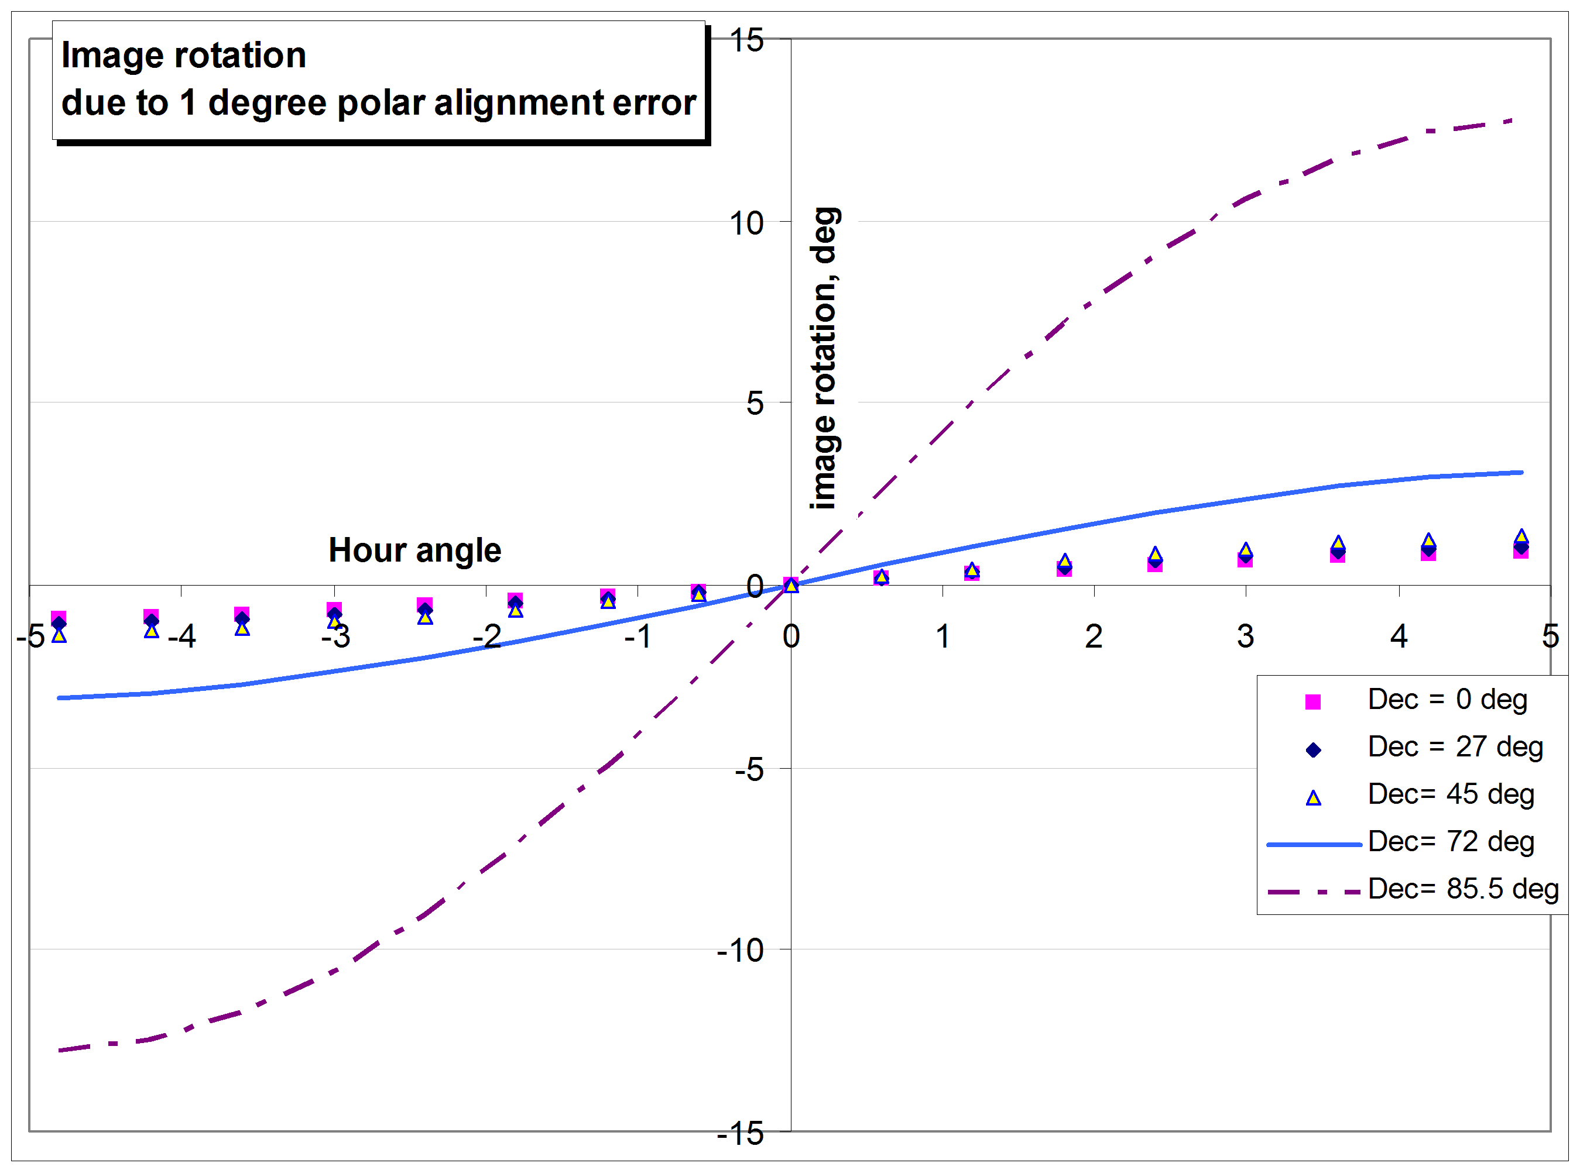

Figure 13: Inadequate polar alignment causes noticeable field rotation at high declinations.

6.3 Exposure – Signal-to-Noise Ratio: The intensity recorded on a pixel of your CCD imager is usually measured in ADU’s (“analog-digital units”), which is a measure of the number of photoelectrons that were accumulated on that pixel during the exposure. This is governed by the statistics of photon arrival, the efficiency with which the chip converts photons into electrons (its quantum efficiency), and the random creation of electrons by thermal and other effects in the sensor. If a series of identical images are made, and you carefully examine the same pixel in each image, the recorded intensity (ADU) won’t be the same number on each image – it will vary because of these (unavoidable) factors. Call the average ADU value S, the “signal”. The RMS variation of the ADU value, N, is the “noise”, and the signal-to-noise ratio is SNR= S/N. If all other noise sources are eliminated, the SNR is set by the statistics of photon arrival, in which case it will be:

$$\text{SNR}=\sqrt{g⋅\text{ADU}}$$

where g is the “gain” of the imager (photoelectrons per ADU). Of course, additional noise sources will reduce the SNR.

The accuracy with which the position of a star can be determined is fundamentally limited by the SNR. One estimate of the achievable astrometric accuracy is

$σ_{\text{ast}}=\frac{\text{FWHM}}{2\text{.}\text{36}⋅{\text{SNR}}_{\text{peak}}}$ arc-sec Eq. 8

where:
FWHM is the full-width-at-half-maximum if the star’s PSF (in arc-seconds)
and
SNR_{peak} is the signal-to-noise ratio of the brightest pixel in the star’s image.

If your observing site’s seeing conditions result in stellar images with FWHM ≈ 3 arc-sec, and you are striving for measurement accuracy of 0.05 arc-sec, this equation implies a minimum requirement for SNR_{peak} ≥ 26. Since there are other noise sources in the image, striving for double this is wise, and it is usually no problem to achieve SNR ≈ 50 with modest exposure duration. (With g≈2.3, this implies a signal of S ≈ 1000 ADU on the brightest pixel).

6.4 Exposure: Dynamic Range: Pairs with large magnitude difference present a special challenge to CCD users, because of the limited dynamic range of the sensor.

Most modern commercial CCD imagers use 16-bit output (ADU values from 0 to 65,535), although there are doubtless some 12-bit units still in use (which can display ADU values from 0 to 4095). The 16 (or 12) bits create a hard limit on the dynamic range that the sensor can record. Suppose, for example, the noise (from photon, dark current, and read noise) is 50 ADU RMS. Suppose further that the primary and secondary stars differ by 6 magnitudes (i.e. intensity ratio = I₁/I₂ = 10^{ΔM/2.5} = 251). If we select an exposure that puts the peak pixel of the primary star at 50,000 ADU – near the saturation level of a 16-bit imager – then the peak pixel of the secondary star will be only 50,000/251 ≈ 200 ADU. We have a very high SNR₁= 50,000/50 = 1000:1 on the primary star, but only SNR₂=200/50= 4:1 on the secondary star. Position measurement of the secondary star at this low SNR would probably have an unacceptably large uncertainty. If the magnitude difference were 7 magnitudes (intensity ratio = I₁/I₂ = 10^{ΔM/2.5} = 631), then the secondary star would be unmeasurable (maybe even undetectable), with peak ADU = 50,000/631 = 79 ADU, and SNR≈ 1.6 in the image. Thus, the limited dynamic range of the imager presents a significant constraint in dealing with pairs with large delta-magnitude. Either the primary star will be saturated (and hence its position not accurately measurable), or else the secondary star will be buried in noise (and hence not accurately measurable).

If your CCD has “anti-blooming gates” (ABG), then its linear dynamic range may be reduced. The output of these sensors tends to become non-linear above about 50% of the full-well depth (i.e. about 32,000 ADU in our example), which aggravates the dynamic range problem.

Large delta-mag systems are a real challenge for CCD measurement! If you want to venture into this territory, the most impressive approach that I’ve seen is that invented by James A. Daley. He makes a small partially-transmitting “occulting mask” by cutting a small strip from a mylar solar filter. This is placed at the focal plane of the telescope, and a lens assembly is used to re-image the (partially occulted) focal plane onto the CCD chip. The target pair can then be placed in the FOV so that the light of the primary star passes through the partial-occulting mask (and is thereby diminished), but the secondary is not occulted. This dramatically reduces the dynamic range of the optical image, and makes accurate measurement of both stars possible. An excellent description of this innovative approach, and its application to large delta-mag systems, is described in a series of articles in JDSO by Mr. Daley – see, for example JDSO v. 3 no. 4 (Fall 2007) p. 159.

A simpler approach – not as robust as Daley’s, but helpful in cases of moderately large delta-mag – is to convert the individual 16-bit images to 32-bit images (several software programs will do this, including MaximDL and MPO Canopus), and then sum a few dozen images together. Summing n images improves the SNR by a factor of $\sqrt{n}$ (i.e. summing 25 images will improve the SNR by a factor of 5). In our example of the Δm ≈ 6 mag pair, this would increase the SNR of the fainter star to a useable SNR≈ 20. Since the summation is done in 32-bit arithmetic, the computation can handle over 2 billion ADU per pixel – a virtually unlimited numerical dynamic range. If you use this approach to dealing with a high-delta-mag pair, you should test your software and calculations on a few summed images of easily measured pairs, to be sure that you understand how your software handles the summation of 32-bit images.

6.5 Filters: Unfiltered images collect the maximum amount of starlight, hence maximize SNR for a given exposure. Many reported double-star measures are based on unfiltered imagery.

You may choose to use a filter to minimize atmospheric dispersion effects and also to minimize the effect of chromatic aberration in your telescope (more likely to be of concern if you are using a short-focus refractor). This will probably require longer exposure, but may well improve the overall accuracy in your measurements. Particularly if you are imaging far from the zenith (say zenith angle > 50 degrees), it may be wise to use a red filter (either the “R” from an RGB imaging filter set, or the “R” or “I” band filter from a photometric BVRI set) to minimize differential chromatic refraction.

Another reason to consider using filters is the case where the primary star is substantially brighter than the secondary. If the two stars have different colors, you may be able to reduce the delta-magnitude between them by judicious selection of a filter. For example, if the primary is red and secondary is blue, try a blue filter: it will dim the primary, and have less effect on the secondary. This may make it possible to get a better SNR on the secondary without saturating the primary.

6.6 Autoguiding: This depends very much on the accuracy of your mount’s tracking, and the exposure that you are using. Try a few experiments to determine the tracking accuracy of your mount without guiding – what fraction “good” images do you get at different exposures? Then decide whether to autoguide based on the exposure that you’re using to capture your target images.

6.7 Science images: Do not ever rely on a single image. There are too many things that can go wrong! If an image has an accidental defect within the measuring aperture (such as a cosmic-ray hit or a “hot” or “cold” pixel) then the calculated position of one or both stars may be erroneous. This risk can be minimized by using multiple images, and allowing the pair to drift a bit between images (so that they don’t sit on the same hot pixel, for example).

Take 6 to 12 images of each pair, so that the range of results will provide a basis for estimating the consistency of the measurement, and to allow for tossing out the occasional obviously flawed image.

Because many WDS pairs are fairly bright, it is often quite feasible to make a great many exposures in a short observing session on a given target. Take advantage of this: some software programs contain utilities that will automatically sort through your images, selecting the “best” ones so that you can then analyze just the dozen best images.

6.8 File formats: Most CCDs give you several options for the format of the stored image data. The astronomical standard is FITS – an uncompressed file format whose header can accept certain useful information from the camera and the telescope (e.g. time and exposure duration of image, RA-Dec and Alt-Az of telescope pointing). This is the preferred format, rather than proprietary or compressed file formats. In particular, compressed image formats such as JPEG may impair routine image processing steps that may be useful in double-star observations. All of the commonly-used CCD image-processing programs can read and manipulate FITS format images.

In the case of DSLR cameras, the choice of file format is usually JPEG or “Raw” (or both). The “Raw” format is recommended, because it contains almost-unprocessed image data which can be manipulated (e.g. summing multiple images) if necessary. Many popular CCD image processing software packages can read and manipulate Nikon and Canon “raw” image files.

6.9 Flats and Darks: Yes, take them and use them! The effects of dust donuts and dark current on double star measurement are usually much less serious than they are on CCD photometry, but nevertheless it is good practice to reduce your images with bias, dark, and flat fields so that you are using the best possible image data in your measurements.

You may be able to imagine worst-case scenarios in which failure to reduce your images can have bad impact on your double star measures. For example, suppose that one of the stars is sitting exactly on the edge of a dust-donut, so that the right half of the PSF is unaffected, but the left half of the PSF is substantially dimmed by the edge of the “donut”. The calculated intensity centroid will be pushed to the right, compared to the “true” position of the star. Or, suppose that a hot pixel is lying in the left wing of the PSF: the intensity centroid will be pulled toward the left, compared to the “true” position of the star. Granted, these are pretty unlikely scenarios. But we’re striving for very high accuracy (say, a tenth of a pixel), and there is no convenient way to notice that your image is corrupted in this way, so it is safer to do the routine CCD image reductions before analyzing your images.

Always save both your raw and reduced images, just in case you discover later that there was something wrong with your darks or flats. This may never happen to you, but I have been known to inadvertently reduce a 1-minute exposure with a 2-minute dark frame; or use my dusty V-band flat on a pristine R-band image. It is nice to be able to retrieve the raw image, and do a corrected reduction!

VII. Considerations Related to Image Analysis

7.1 Are E and Δ constant across your entire FOV? In Eq. 4 and Eq. 5, we determined the plate scale (E) and image orientation (Δ) by measuring a single “known pair”, at one location in the image field of view. It is reasonable to ask, “Are those values the same across the entire field?” The answer is, “You won’t know unless you check your system”.

For the systems that most double-star observers use, having relatively long focal-ratio telescopes (F/6 to F/10 or longer) and relatively narrow image fields of view (less than a degree), most likely you won’t see any significant variation in E or Δ across the field. Nevertheless, it is conceivable that your system may have some optical aberration that affects E or Δ – field curvature or pincushion distortion, for example. Therefore, it is worthwhile to do a one-time check of your system. Take a series of images of a few “known pairs”, moving the telescope slightly to position the “known pair” near each of the four corners, and near the center of your field of view. Calculate E and Δ separately for each image, and for each “known pair”. If there is no significant change in E or Δ across the FOV, then you can be confident that your system’s image scale and orientation are indeed “constant”.

Suppose that your system shows a non-constant E or Δ. What then? This isn’t a fatal issue. Depending on your method of image analysis, there are straightforward ways to deal with it. If the values of E or Δ are constant over the center portion of your FOV, and only change noticeably near the corners, then just be sure to put your target pairs within the “sweet region” of the FOV, and avoid the corners of the frame.

If you are using “astrometric fitting” to determine the RA, Dec coordinates of the two stars in a pair, consider using higher-order plate constants, which can accommodate the effects of changing E and Δ across the field. “First-order” plate constants implicitly assume that E and Δ are constants, whereas quadratic, cubic, or 4th-order plate constants can model most optical aberrations.

7.2 “Known pairs”, WDS “Calibration pairs” and “Synthetic calibration pairs”: The “image scale and orientation method” requires that you make images of one (or preferably, several) pairs whose separation and position angle are reliably known. Ideally, these “known pairs” will also be reasonably close in the sky to your targets for the night (to minimize any errors that might be introduced by field rotation caused by imperfect polar alignment of your telescope mount).

If you think through the math involved in determining the image scale (E) and orientation (Δ), you’ll recognize that it is advantageous for these “known pairs” to have reasonably large separation. If the stars of your “known pair” are separated by only a few pixels, then an error of a fraction of a pixel in determining their centroids can be a sizable percentage of the total separation; this means that the determination of plate scale (E) may be uncertain by a sizable percentage. Similarly, if the pair is separated by only a few pixels then a small error in the centroid of either star can result in a sizable error in the calculated image orientation (Δ). In general, you are advised to select “known pairs” whose separation is at least 10 times the FWHM of your image, and whose components are fairly equal in brightness (say within ±0.5 magnitude).

Where do you find useful “known pairs”? The WDS contains a link to a set of “calibration pairs”, whose orbits are well-attested, or which are known to be relatively fixed. These can be used as “known pairs”, but there are a limited number of them, so it may not be possible to find a useable one that is near in the sky to your target pairs. Most of these catalogued “calibration pairs” tend to be quite close (a few arc-seconds or less). If your system has high resolution (say, Δθ ≤ 0.5 arc-sec), and your site has excellent seeing (FWHM ≈ 1-2 arc-sec), then some of the WDS “calibration pairs” may help you calibrate your system.

Another useful source is the WDS Catalog of Rectilinear Elements. This is a catalog of star pairs whose motion appears to be linear (rather than curved orbits), and whose ephemerides are of good quality. There are quite a few widely-spaced pairs in this catalog, which may make better choices for calibrating your system. Of course, with either the “calibration pairs” or the “rectilinear elements” pairs, you are calibrating your image scale based on other people’s measurements of these double stars, and so your calibration is in a sense dependent on the very thing that you want to measure – double stars – and that adds a bit of potential uncertainty into your calibration. Part of this uncertainty can be removed by using star trails to determine your image orientation – star trails are a truly independent estimator of image orientation.

You can also make your own “known pairs” with your Planetarium program. Widely-used programs such as TheSky and SkyMapPro that use the Guide Star Catalog as their primary stellar database are just fine in this regard. Pick any two stars that are nicely placed in your image, and separated by 10-20X FWHM. From your planetarium program, determine their RA, Dec coordinates. Then, use equations Eq. 1 and Eq. 2 to determine their separation and position angle. Now you can use that pair of stars as a “calibration pair” for your system. (Some planetarium programs – TheSky is one – will calculate the separation and position angle for you, saving you from the calculations of Eq. 1 and Eq. 2.) Repeat the calculations on several images, and use several different star-pairs, to confirm that your determination of E and Δ is stable. If you measure several “calibration pairs” (WDS or synthetic) to determine E and Δ, use the average determined values for reduction of your target pairs.

7.3 Summing Images: In general, only the bare minimum of image processing should be done to your science images. In particular, only “linear” operations should be done (i.e. no sharpening or deconvolution!)

There are situations where it may be useful to align and add multiple images before measuring ρ, θ. Summing is a linear operation, so it is allowed as a way to improve the SNR (however note the discussion of dynamic range above). Reduce your images (flats, darks, and bias) before summing them.

7.4 What if I can’t get an astrometric match to my image? It happens occasionally that a relatively bright double star is located in a sparse field, so that when you take the necessarily short exposure image to avoid saturating the double star, you don’t capture a sufficient number of field stars to make a good astrometric fit. Your software will report “unable to match” or some similar error message. There are two tricks that can help in this situation.

Most image-processing programs can align and stack (add) multiple images. This will increase the signal from faint field stars, but it is not in itself a cure-all, because if the original 16-bit image was close to saturating on the primary star of your target pair, then summing several images would only aggravate that problem. Some image processing programs (e.g. MPO Canopus and MaximDL) will sum the images in 32-bit arithmetic, and store the summed image as a 32-bit file. That essentially eliminates the “numerical saturation” problem, and so you may be able to get a good astrometric match on the summed image.

You can also take a longer-exposure image – long enough to bring out the faint field stars to enable the program to “match” the image to its star catalog. Your target pair will, of course, be saturated on that long-exposure image, but you can use the transformation matrix (or image scale and orientation) from the long-exposure image to analyze your “short exposure” image.

This approach – using the transformation determined on one image and applying it to a different image – may seem to be playing fast and loose with the astrometry, even if the two images are taken sequentially and of the same field of view. The reason that it is less risky than it seems is that the separation and position angle of the target pair depend on their positions relative to each other, not on their absolute pixel coordinates. Refer back to Eq. 4 and note that if a constant number were added to both x₁ and x₂, the calculated separation wouldn’t change. The same is true of the calculated position angle – the calculated ρ and θ are insensitive to small shifts between the images. If the telescope and camera are well-behaved and if the “long” and “short” exposures are taken sequentially with no jostling of the camera or mount, and there is no risk of the camera rotating in the focuser between images, this method works fine.

VIII. Accuracy and Reliability

All scientific measurements should be accompanied by an estimate of their accuracy. This estimate can sometimes be based on theoretical models (such as Eq. 8), but these models contain a host of assumptions that may be difficult to justify. (For example, Eq. 8 implicitly assumes that the noise is truly random and uncorrelated from pixel to pixel – it takes no account of fixed-pattern noise such as dust donuts). The best that can be done in many cases is to infer the accuracy of your measurements by analyzing the measurements themselves.

8.1 Assessing the Accuracy and Reliability of your measurements

Assessing the quality of your double-star measurements is a bit tricky, because for most pairs, there isn’t a “textbook answer” that you know is correct. You measure θ= 45.6 tonight. A decade ago, someone else measured θ= 46.2. Who is right? Maybe both are – the pair’s relative orientation may very well have changed in the intervening years. Maybe one is accurate, but the other is mistaken. Maybe the two measurements are identical in a statistical sense, for example if both measurements are uncertain to ± 1 degree.

Practices that enable you to assess the accuracy and reliability of your measurements are:
- make multiple measurements of your target, by taking a handful of images on each of two or more nights
- examine the internal consistency of your measurements (both the standard deviation and the full range)
- include a few well-attested pairs in your observing plan

The average of several measurements is more reliable than any single measurement (this applies to almost all measuring activities, not just double stars). By measuring multiple images and averaging the results, you improve the reliability and reduce the probable error in the reported value, because you are “averaging down” the effects of noise and other image artifacts. Making images of the pair on two or three different nights will help prevent accidental errors, such as imaging the wrong star, or being misled by a passing asteroid.

Making (and analyzing) multiple images is also meritorious because the spread of the measured values gives you some insight into the accuracy of your result. For example, if all of your measurements of the pair’s separation fall within ±0.2 arc-sec of the average value, you can report that your position is accurate to ±0.2 arc-sec. This helps other researchers interpret your data, and compare it to other people’s measurements. Or, suppose that you take 6 images, and all of the calculated separations are nearly the same (±0.2 arc-sec, say), except for one that differs by 1.5 arc-sec. That is a sign that there is something odd. Examine all of the images – is the “outlier” unusual or corrupted in some way (cosmic ray hit near the target star? dimmed by a passing cloud? affected by an asteroid passing by?) Or is it perhaps the only “good” image in the set, and the only accurate measurement? Critical examination may help you decide what to do – toss out the one discordant image, toss out the 5 corrupted images, or conclude that a fresh batch of images should be taken.

I always try to include one well-attested pair in each night’s list of targets. If my subsequent reduction matches the published ρ,θ for the pair, fine. But if my reduction of this “well attested” pair is significantly different from its published value, that is a clue that something may have gone awry. The situation needs to be investigated and resolved before I have confidence in the measurement of other pairs from that night.

Including these “known” pairs in your reports is also a useful discipline. It gives the user of your data an opportunity to assess the quality of your measurements (of this particular pair), and apply that judgment to other pairs in your report. If you don’t include a few “known” pairs in your report, then the user has no way of assessing the relative quality of your measurements.

By the way, in this context it is worth noting that when you publish your measurements and they are entered into the WDS, they are permanently tagged with your name. For good or ill, future astronomers will not only be able to see your measurements, but they will also see that you were the observer who made/reported them. So, if you are not confident in the accuracy and reliability of your measurements, it is better to repeat the observation/analysis, rather than to publish dubious results. Your astronomical reputation may depend on it!

Both for the benefit of the astronomers who use your data, and for your own peace of mind, it is a good idea to (at least once) measure a few “calibration pairs” (available on the WDS). I recommend picking a range of pairs, from quite wide to as close as you can imagine splitting (say ρ≈ 3 pixels). By comparing your results to the ephemeris for each pair, you will confirm that your measurements are accurate and reliable (to within your uncertainty). Perhaps more importantly, you will get an idea of the limits of your system’s reliability. If your equipment can’t reliably measure pairs closer than 3 arc-sec, for example, then you know to concentrate on wider pairs.

8.2 Precession
Because of the way the celestial coordinate frame is defined, the orientation of the celestial coordinate system is not permanently locked in place – it changes slowly (but predictably) as the Earth’s rotational and orbital parameters evolve. Hence, celestial positions may be referred to the “equinox and pole of 2000” (J2000), or “equinox and pole of the epoch of observations” (i.e. the coordinate frame as it existed at the time the image was taken). At the level of accuracy that we’re talking about here (fractions of an arc-second), a star’s celestial coordinates change noticeably in just a few years.

Of course, the distance between two stars isn’t affected by precession. But the position angle is affected by precession, because the direction toward North – the reference line of position angle – is continuously changing as the position of the north celestial pole wanders.

Because of the heritage to the days of filar micrometers, the convention is that a pair’s position angle is reported relative to the pole and equator of the date of the observation. (If you set up your filar micrometer by monitoring a star’s drift with the clock drive off, then you were automatically referring to the instantaneous pole at the time of your observation). But, if you do an astrometric match of your CCD image to a standard astrometric star catalog, your transformation will report the RA, Dec based on the pole position of the epoch of the catalog (normally J2000 for modern catalogs). So, if you make your measurements based on astrometric fitting, you may need to correct them for precession before reporting them.

I say “may” for two reasons. First, the precession-correction is greatest near the celestial pole, and it shrinks rapidly once you are more than about 10 degrees from the pole. For declinations less than about 80 degrees, you can safely ignore this tiny correction, at least until around 2050 if you are using a modern J2000 star catalog for astrometric fitting of your images.

If you are involved in a project where precession correction is important, refer to Chapter __ for the relevant equations and instructions. Alternatively, if you use MPO Canopus, its double-star utility has an option to correct the position angle for precession before displaying it.

Similarly, if you request the historical record of observations of a pair from the WDS, each of those observations will be referenced to the pole of the epoch of the observation.

8.3 Reporting Your Measures

A double star measurement that languishes in your observing notebook is of no value to other astronomers! The Washington Double Star catalog is the IAU’s official repository of double-star measures (and other information related to double stars, such as delta-magnitude and color indices). However, you cannot submit measures directly to the WDS. Instead, measures are published in the scientific literature, and the managers of the WDS then enter published measures into the official catalog.

The principle US venue for reporting double-star measures is the quarterly Journal of Double-Star Observations (www.jdso.org), published at the University of South Alabama. Although this is a US publication, the editors welcome contributions (in English) from anywhere in the world. Distribution is free over the internet.

The Webb Society (http://www.webbdeepsky.com) Double Star Section publishes double star measurements in its annual Circulars, making them available to other observers and to the WDS.

In Spain, the web-based “El Observador de Estrellas Dobles” (http://elobservadordeestrellasdobles.wordpress.com) is the journal of record for double-star science.

In France, Observations et Travaux, the technical journal of the Société Astronomique de France, welcomes contributions of double-star measurements. If the paper is submitted in a language other than French, as far as possible the paper will be printed in both its original language and in French translation.

IX. References

Berkó, Ernõ, “Double Star Measures Using a DSLR Camera”, Journal of Double Star Observations, Vol 4, No. 4 (Fall 2008), p. 144 http://www.jdso.org/volume4/number4/Berko.pdf

Buchheim, R. K. “CCD Measurements of Visual Double Stars”, SAS Symposium (2008) http://socastrosci.org/images/SAS_2008_Proceedings.pdf

Buchheim, R. K. “CCD Double Star Observations at Altimira Observatory: Spring 2008”, Journal of Double Star Observations, Vol. 4 No. 3 (Summer 2008), p. 103 http://www.jdso.org/volume4/number3/Buchheim.pdf

Daley, James A., “A Method of Measuring High Delta m Doubles”, Journal of Double Star Observations, Vol. 3 No. 4 (Fall 2007) p. 159 (http://www.jdso.org/volume3/number4/Daley.pdf)

Espin, T.E., “Micrometrical measurements of double stars (13th series) and New Double Stars, Monthly Notices of the Royal Astronomical Society, v.79, p. 211 (1919) = includes discovery report of MLB 102

Filippenko, A.V., “The Importance of Atmospheric Differential Refraction in Spectrophotometry”, Publications of the Astronomical Society of the Pacific, v. 94, p. 715 (August, 1982)

Lindegren, L., “Atmospheric Limitations of Narrow-field Optical Astrometry”, Astron. Astrophys. v. 89, p. 41 (1980)

Milburn, W., “The Rev. T.H.E.C. Espin”, The Observatory, v.58, p. 27 (1935)

-----, Monthly Notices of the Royal Astronomical Society, v. 95, p. 319 (Espin obituary)

Monet, David G., et al, “U.S. Naval Observatory CCD Parallaxes of Faint Stars. I. Program Description and First Results”, The Astronomical Journal, v. 103, No. 3 p. 638 (February 1992)

Raab, H., “Detecting and Measuring Faint Point Sources With a CCD”, in Proceedings of the Meeting on Asteroid and Comets in Europe, 2003, May 1-4, 2003, Costitx, Majorca, Spain.

Slocum, F., “Effects of Atmospheric Dispersion Upon Determinations of Stellar Parallax”, Astrophysical Journal, v. 59, p. 108 (1924)

Wright, D. C., “Double Star Astronomy in the UK 1832-1932”, Quarterly Journal of the Royal Astronomical Society, v. 34, p. 423 (1993)

