Occultations

Introduction.
One of the difficulties of observing and accurately measuring the relative positions and magnitudes of components of double stars is their mutual interference. Either one component is much brighter than the other, or the apparent separation between them is too small to be resolved by the optical system, particularly in the presence of distortion by the Earth’s atmosphere. Ideally the components could be obscured one after the other to allow unambiguous observation of the companion as well as an estimate of the separation between them. This in essence is the principle behind application of the occultation technique to the observation of double stars.

Now, the Moon in its orbit around the Earth-Moon barycentre frequently obscures (occults) stars. As a consequence both of the inclination of the Moon's orbit with respect to the ecliptic and the precession along the ecliptic of the nodes of the Moon's orbit, all the stars in a belt of some 10 degrees around that plain are occulted at some time during a period of about nine years. Among these are the bright stars Aldebaran, Regulus, Spica, and Antares and the star clusters Pleiades, Hyades and Praesepe. Since the Moon always moves eastward, an occulted star disappears at the Moon's eastern limb and reappears at its western limb. The phenomena can be best observed at the dark limb of the Moon, so in general disappearances are best observed each month during the two weeks between New and Full Moon, and reappearances during the following two weeks. Since the invention of the telescope, professional and amateur observers using a variety of techniques and instrumentation have recorded many thousands of timed observations of lunar occultations. Analyses of these observations have addressed such problems as improving the dynamical theory of the motion of the Moon, investigating the variable rate of rotation of the Earth, determining stellar reference frame anomalies, measuring apparent stellar diameters and parameters in multiple star systems. It is the last two items that are of particular relevance to the subject of this chapter, but in the following sections the power of the occultation technique will be examined with reference to all of these applications. Indeed, in a recent message on the website of the excellent International Occultation Timing Association (IOTA), Dunham et al (1) strongly support the continuance of occultation observations, in particular for these two applications, stellar reference frame and double stars.

Observation
The scientific observation of an occultation involves accurately recording the instant at which the star disappears behind or reappears from behind the lunar limb. In all but occultations of the brightest stars, telescopic or binocular aid is essential for making an accurate measurement; as the Moon approaches the star the glare from the sunlit part of the disk totally overwhelms the light from the star. By using optical aid to restrict the field of view, in most cases the star can be seen clearly at the moment of occultation.
The Moon orbits the Earth in approximately 28 days, which leads to an average Easterly motion against the background of stars at a rate of 0.5 arc-seconds per second of time. If the instant of occultation can be estimated to a precision of 0.1s, then the relative position of the lunar limb and the star is known at that instant to a precision of 0.05 arc-seconds. The analysis of such observations proceeds by the computation both of the position of the center of the Moon at that instant by interpolation in a lunar ephemeris and a precise knowledge of the position of the observer on the Earth’s surface, and the position of the star taken from an appropriate star catalogue. Also, the lunar limb is not smooth; it has roughness of apparent angular extent ± 2 arc-seconds, caused by variations in the level of the lunar terrain along the line of sight from star to observer. From this information, the apparent distance of the star from the lunar limb at the instant of recorded occultation may be calculated. Almost certainly, the computation will imply that the star should have been occulted at a slightly different time than that recorded by the observer. The reasons for the discrepancy will include errors in all the assumptions made to compute the circumstances of the occultation, such as very small errors in the position of the star given in the catalogue and very small errors in the lunar ephemeris, and larger errors in the charts used to derive the level of the lunar terrain. A further correction will be attributable to the method used to make the observation. No matter how well prepared and experienced the observer, there is inevitably a time delay between the instant that the observer perceives and then records the event. If a stopwatch is used to record the event, it has been estimated (2) that this delay, or personal equation, is on average about 0.3 seconds for a disappearance and 0.5 seconds for reappearance, the larger value for the latter being due to the intrinsic ‘surprise’ element of this type of event. Another recording technique in common use is the so-called eye-and-ear method: the observer listens to an audible one-second time signal whilst concentrating on making the observation, then mentally estimates the time of the event as a fractional part of a second. Results of analyses (2) suggest that this method is essentially free from personal equation effects, with observers achieving measurement precisions of about 0.1 seconds. However, despite such impressive precision acheivable from visual methods, a far more accurate technique is to record the occultation events electronically. Two electronic methods exist: a photomultiplier tube (PMT) or a digital video camera attached to the telescope. The PMT is used to count individual photons reaching the telescope from the star, and the counts are integrated and digitally recorded over contiguous, short time intervals, of duration typically one milli-second. The resulting light curve can then be analysed to determine, among other quantities, the instant of occultation with precision close to one milli-second, as well as apparent stellar diameter. When using a digital video camera, typical frame-rates are 25 frames-per-second (fps). Analysis of the frames thus returns the instant of occultation at a resolution of about 80 milli-seconds (ms).

Double stars
These then are the techniques of lunar occultation observation, where the star being occulted is a single star. If the star is in fact a double or a binary system, the intrinsic spatial resolution of the technique can be exploited to determine several useful parameters, depending upon the observing method. If the times of occultation of each of the components are measured by one of the techniques discussed above, then the separation of the components ξ, projected onto the apparent direction of motion of the Moon, can be determined simply from ξ= Δt.r, where Δt is the difference in time between the two events, and r is the rate of motion of the Moon. Now also
ξ=ρ.cos(θ−φ), where ρ,θ are respectively the true angular separation and position angle of the double star components, and ϕ is the position angle of the occultation event on the lunar limb. The situation is illustrated in Figure 1, where the 'red' star is about to be occulted by the limb of the Moon. The 'blue' component of the double star is separated from the red component by distance ρ in position angle θ. The distance measured by the observed time difference Δt is the projected separation ξ. Provided that the personal equation effects discussed above are the same for each of the two events, then the accuracy of determination of ξ is limited only by the resolution of the timing technique. Of course, from observations of a single event it is not possible to determine ρ and θ. However, if a series of observations of the same double star is obtained either from different locations on the Earth or over a period of time, such that a range of values of φ is achieved, statistical methods can be used to estimate the values of ρ and θ from the deduced values of ξ. Most prediction packages that may be obtained from the reference given in the Resources Section of this chapter include for each event the values of position angle ϕ and rate of motion r of the lunar limb.

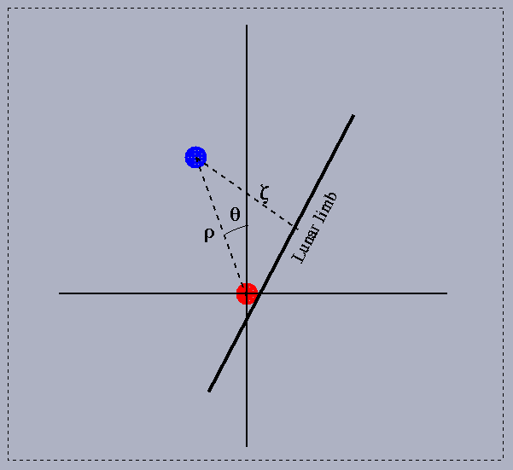
Figure 1. Schematic of an occultation of a double star; the components are separated
by angular distance ρ in position angle θ. The projected separation ξ may
be estimated from the time difference between the two occultation events.

Visual Observations.
This discussion implies that both components of the system are visually resolved during the occultation; if the components are too close together to be resolved, then the observed effect has been determined (3) to depend both on the apparent separation of the components and on their relative brightness. An analysis of a large number of occultation observations that had been made over some 35 years showed that for more than 420 of these observations the observer reported an anomalous event. The observers recorded these occultation events as not to have occurred instantaneously, to have ‘faded’ either smoothly or in a stepwise fashion. For 160 of these events, it was found during the analysis that the 140 stars involved were in fact close doubles, many of which had been discovered by other techniques at later dates. For many of these known double and binary systems their separations and position angles were sufficiently well known to enable a calculation of the expected time intervals Λt between the occultations of the two components, and whether the brighter or fainter component was occulted first. Intuitively it may be expected that for components of similar magnitude and for close doubles where the two occultations follow in rapid succession, the event may appear gradual, taking a slightly longer time to complete than the more normal instantaneous disappearance or reappearance. However, for wider pairs, or where the difference in magnitude of the components is large, the event might be expected to appear more dramatic, with a clear drop or step in brightness after the occultation of the first component. This expectation is born out by the data, as shown in Figure 2, where for each of the observations the calculated event duration is plotted against the computed brightness-change after the occultation of the first component. The observers’ comments from the original observation records have been interpreted as either ‘gradual’ or ‘step’ event, and used to code the observation symbol on the plot; circles for ‘gradual’ and crosses for ‘steps’. It is clearly seen that the observations are split into two classes according to whether there was a large change in brightness or long duration (step observed), or subtle change in brightness or short duration (gradual event). These results may then be used as a rough guide to interpret further visual observations of occultations, where a non-instantaneous event is observed.
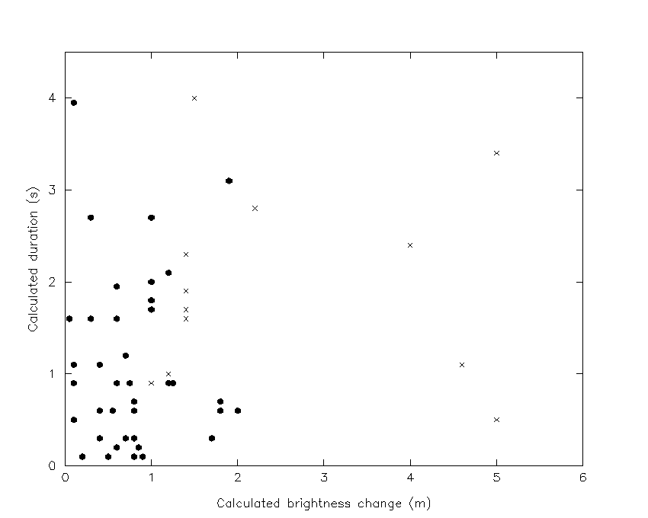

Figure 2. Observed event for known double stars as a function of calculated
duration and brightness change; circle = ’gradual’, cross = ’step’

The analysis discussed above concluded that a further 130 stars from Robertson’s Zodiacal catalogue (4) were possibly undiscovered close doubles and would warrant closer study by say speckle interferometry, or high-speed photometric observation of future lunar occultations. At least one star, in the Praesepe cluster, from the target list given in (3) has later been confirmed as double as a result of this work (5).
Given in Table 1 is a small subset of this target list showing just those stars that have been observed to fade at occultation on at least three occasions. The stars are identified by their HD, ZC and SAO numbers and visual magnitude.

HD | ZC | SAO | m_{v}
16302 | 387 | 75476 | 6.9
22017 | 516 | 93487 | 7.3
23288 | 536 | 76126 | 5.4
27934 | 656 | 76601 | 4.4
65736 | 1203 | 97468 | 7.1
88802 | 1500 | 118181 | 8.1
89307 | 1506 | 99049 | 7.1
120235 | 1978 | 139559 | 6.6

Table 1. List of stars that have been observed to fade on at least three occasions.

Photoelectric Observations
Naturally, if the photoelectric method is used to observe occultations, detection of much closer pairs should be possible. For high-speed photometry with millisecond (ms) resolution, separations of a few milliarc-seconds (mas) should be detectable, far exceeding the diffraction limit of the telescope being used. However, such observations are not straightforward to analyse, since diffraction and stellar diameter effects dominate the high-resolution light-curves. During an occultation event a series of alternating bright and dark fringes, the Fresnel zones, are generated and cross the telescope field of view during an interval of some 40ms. The first zone, across which the intensity of the light drops smoothly to zero from a value 1.4 times its pre-occultation level, is about 13m wide on the surface of the Earth and subtends an angle of about 8mas at the distance of the Moon. Stars with apparent angular diameter less than about 1mas will generate a diffraction pattern close to that expected from a point source. Those with diameters significantly greater than this will create patterns that can be considered as the sum of a series of point-source diffraction patterns displaced in time relative to each other (6). Thus for high-speed measurement of an occultation event where the diffraction pattern is sampled say at a resolution of 1ms, the characteristics of the resulting light-curve will depend upon the diameter of the star. This effect is illustrated in Figure 3, where theoretical light curves are computed for a point source and for a star of angular diameter 6 mas. The light-curves illustrated here have been further modified from the purely theoretical ones to take account of a realistic bandwidth of the detector system and non-zero telescope aperture (modeled as 50 cm).
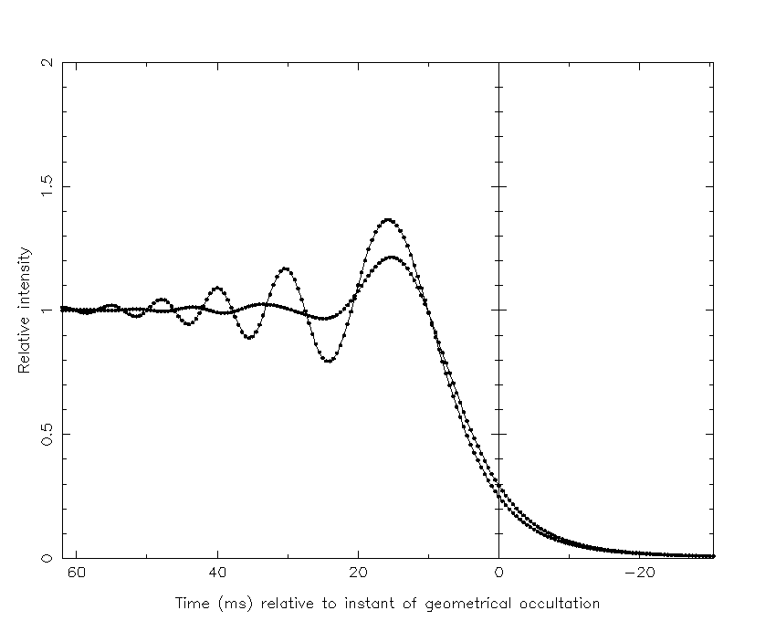

Figure 3. Theoretical light-curves for occultation of a point-source (oscillating curve)
and for a star of angular diameter 6mas (smoother curve).

The variation apparent in Figure 3 of the shape of the light curve as a function of stellar angular diameter can of course be exploited in the analysis of observed light curves; both the precise time of occultation and the stellar diameter may be estimated
by non-linear least squares methods. An initial estimate of the diameter is made, perhaps from previous observations or from theoretical considerations based upon the star’s spectral characteristic (7) and used to compute an approximate light curve. This is then compared point-by-point with the observed light curve and the differences used to solve for corrections to the initial estimate. The process is repeated until convergence is reached and depending upon the quality and signal-to-noise ratio of the data, precisions of better than 1 mas may be achieved. In practice several other parameters are solved simultaneously with stellar diameter, such as an estimate of the brightness of the star, the background noise and rate of motion of the lunar limb. A large number of stellar diameter measurements has been obtained by this method and published in the astronomical literature. Figure 4 shows an example of an occultation recorded and analysed in this way by the author, using a PMT attached to the 50cm laser ranging telescope of the Natural Environment Research Council Space Geodesy Facility (SGF) at Herstmonceux, UK (http://sgf.rgo.ac.uk). The value of each point in the plot has been scaled from the total number of photons reconded by the electronics in each 1-millisecond time-bin. The smooth curve (red) is a best-fit theoretical model developed by the author from the work published by Evans in reference (5), as outlined above. The best-fit model implies an apparent stellar diameter of 5±1 mas. Clearly, the method can readily be used for the analysis and discovery of close double stars. If evidence of duplicity is suspected in an observed light curve, the modeling process is extended in order to compute a theoretical curve by summing two such curves displaced in time and amplitude by the initial estimates of component separation and brightness and lunar limb-rate. The fitting process is identical to the

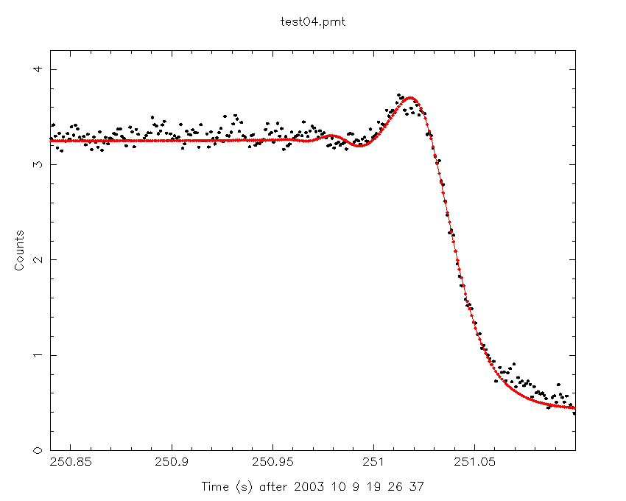

Figure 4. High-speed photometric observations of a lunar occultation; the black dots are photometer counts at 1-ms intervals from the star; the red curve is a theoretical model fitted to the data.

single-star case, except that now two diameters may be estimated along with the parameters of the double star system. The results of such analyses are of course the same as for the visual observation method, in the sense that only the component of the double star separation in the direction of motion of the lunar limb is determined from a single observation. However, separations as small as a few mas are detectable. This is an ongoing programme of spare-time telescope work at SGF Herstmonceux.

Digital video camera observations
The digital camera method is currently very popular since quite cheap and light-weight devices are readilly available. In addition, very good results may be obtained in a straightforward way and without the need for the model fitting that is required for analysis of photometric light-curves. Visual or automated scanning of the individual camera frames will reveal the instant(s) of occultation of each component of a multiple system, or allow discovery of unknown doubles. Given the typical frame rate and the fact that at least two frames are required to detect an event, typical separation resolution is at a level of between 40 and 20 mas, dependent on the apparent rate of the lunar limb relative to the stars. Recently published work using this method (8) give projected separations for some 25 double stars.

Summary
The occultation technique is seen to be a valuable tool for serendipitous discovery as well as measurement of known double stars. Accurate visual timing of the individual occultation events can lead to determination of minimum separations at sub-100 mas levels of precision, as well as estimates of the relative brightness of the components. High-speed photometric observations are capable of mas-level detection and measurement, and video-camera tecniques can measure separations of 40 mas and above.

Resources
A great deal of information on the occultation technique may be obtained from the International Occultation Timing Association. The website at
http://www.lunar-occultations.com/iota/iotandx.htm gives prediction information, software and links to further resources.

References

- Dunham, D., Herald, D., Soma, M., 2010. IOTA, http://www.lunar-occultations.com/iota/iotandx.htm

- Morrison, L.V., Appleby, G.M. 1981. Analysis of Lunar Occultations – II. Personal Equation. Mon. Not. R. astr. Soc., 196, 1005.

- Appleby, G.M., 1980. Fading Occultations of Stars by the Moon: 1943-1977. J. Brit. Astron. Assoc., 90, 6

- Robertson, J., 1940. The New Zodiacal Catalogue. Astr. Pap. Washington, X, Part II

- McAlister, H.A., Hartkopf, W.I., Sowell, J.R., Dombrowski, E.G. and Franz, O.G. (1989). ICCD Speckle Observations of Binary Stars. IV. Astron. J. 97, 510.

- Evans, D.S., 1971. Astron. J., 76, 1107.

- Barnes, T.G. and Evans, D.S., 1976. Mon. Not. R. Astron. Soc., 174, 503.

- Loader, B., Bradshaw, J., Breit, D., et al; 2011. Lunar Occultation Observations of Double Stars – Report 2, Journal of Double Star Observations, Vol 7, No. 3.

